KEYNOTE SPEECHES
1. If learners do not learn anything, 2. The Andalusian Heritage in
can we still regard this as teaching? Learning Arabic as a Second Language
By: By:
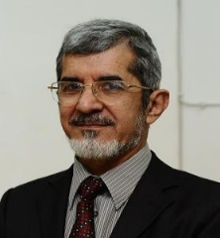
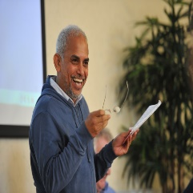

Prof. Dr. Jayakaran Mukundan –  Recipient of Anugerah Akademik Negara, 2013.  An educationist, a researcher and a writer.  Faculty of Educational Studies  Universiti Putra Malaysia | Prof.Dr. Munjid Mustafa Bahjat –  An expert in the Andalusian and Islamic literature.  Department of Arabic Language and Literature,  Kulliyyah of Islamic Revealed Knowledge and Human Sciences,  International Islamic University Malaysia.

