Title, Times New Roman 14, Bold

First Author’s Full name¹, other authors’ full names (Times New Roman 11, Bold)

Full address of author(s) e.g. Faculty of …., Universiti Teknologi MARA
40450 Shah Alam, Selangor, Malaysia (Times New Roman 11, Italic)
¹Email: corresponding author’s email address (Times New Roman 11, Italic)

ABSTRACT (Capital letter, Times New Roman 12, Bold)
Contents of abstract (Times New Roman 11, Italic, single space)

Keywords: (Times New Roman 11, Italic, single space)

Introduction (Times New Roman 12, Bold, Title case not capital letter, please do not use numbering)

Contents of introduction (indent First line of each paragraph, Times New Roman 11, single space, Justify)

Sub heading 1 (Times New Roman 12, Bold, Title case not capital letter, please do not use numbering)
Contents (indent First line of each paragraph, Times New Roman 11, single space, Justify)

Table 1: The list of
Notes : Taken from MZJ Team Resources

Sub heading 2 (Times New Roman 12, Bold, Title case not capital letter, please do not use numbering)
Contents (indent First line of each paragraph, Times New Roman 11, single space, Justify)
On the Insert tab, the galleries include items that are designed to coordinate with the overall look of your document. You can use these galleries to insert tables, headers, footers, lists, cover pages, and other document building blocks. When you create pictures, charts, or diagrams, they also coordinate with your current document look.
You can easily change the formatting of selected text in the document text by choosing a look for the selected text from the Quick Styles gallery on the Home tab. You can also format text directly by using the other controls on the Home tab. Most controls offer a choice of using the look from the current theme or using a format that you specify directly.
To change the overall look of your document, choose new Theme elements on the Page Layout tab. To change the looks available in the Quick Style gallery, use the Change Current Quick Style Set command. Both the Themes gallery and the Quick Styles gallery provide reset commands so that you can always restore the look of your document to the original contained in your current template.

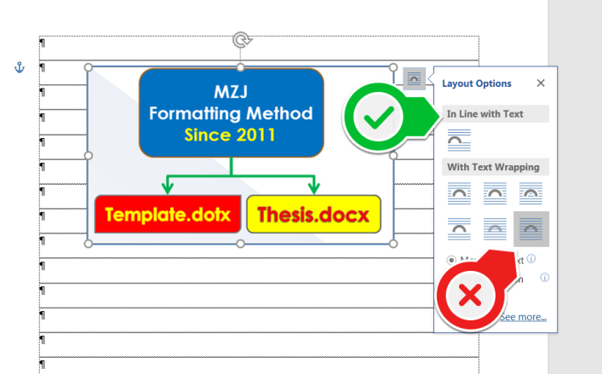
Figure 1: Title is here
Conclusion (Times New Roman 12, Bold, Title case not capital letter, please do not use numbering)
Contents (indent First line of each paragraph, Times New Roman 11, single space, Justify)

References (Times New Roman 12, Bold, Title case not capital letter, please do not use numbering)
Indent second line (Times New Roman 11, single space, justify) e.g. Besser, H. (2003). The next digital divides. Title of Journal, 4(1), xx-xx.
Vol number issue number page number

If retrieved from the web, please include:
Retrieved on 10 October 2009, from http://tcla.gseis.ucla.edu/divide/politcs/besser.html.
Please use sentence case for title of paper, book etc.
Other formatting
Title of Table (Times New Roman 11, Title case not capital letter, BOLD, centre, should be above table)
Figure (Times New Roman 11, Title case not capital letter, BOLD, centre, should be below figure)
Indicator/notes to Table or Figure (Times New Roman 10)

If you use any non English or abbreviation such as et al., please Italic
In text citation, e.g. (Kotler, Bowen & Makens, 2010). The ‘and’ should be ‘&’. However a full spelling of and should be used in the reference list.

