THE ENTREPRENEUR'S CHARACTERISTICS FROM ISLAMIC PERSPECTIVE (TNR, 12, BOLD, CENTRE, UPPER CASE)

Salbiah Nur Shahrul Azmi¹, Suzana Ab. Rahman, Farah Saniah Mohd Zabidi, Rositah Kambol
(TNR, 11, BOLD, CENTRE, SENTENCE CASE)

¹Lecturer at Faculty of Business Innovation and Accountancy, Universiti Melaka, Corresponding Email: salbiahnur@unimel.edu.my.(DESIGNATION, DEPARTMENT, INSTITUTION, EMAIL ADDRESS)
(TNR, 11, CENTRE, SENTENCE CASE)

ABSTRACT (TNR, 11, BOLD, LEFT INDENT, UPPER CASE)

Entrepreneurship is crucial in Islamic economics and businesses..(TNR, 11, ITALIC, SENTENCE CASE, JUSTIFY, MAXIMUM 150 WORDS)

Keywords: Entrepreneur, (TNR, 11, ITALIC, JUSTIFY, SENTENCE CASE, MAXIMUM 5 KEYWORDS)

INTRODUCTION (TNR, 11, BOLD, UPPER CASE FOR EVERY TOPIC)

Entrepreneur is someone who exercises initiative…….(TNR, 11 SENTENCE CASE, JUSTIFY, NO SPACING BETWEEN EACH PARAGRAPH & NO TAB FOR EVERY FIRST PARAGRAPH)

Table 1: xxxx
(TNR, 11, CENTRE, CAPITAL EACH WORD)
Items | Value
A | 0.51
B | 0.22
C | 0.35

Source : xxxx (TNR, 11, LEFT, CAPITAL EACH WORD)

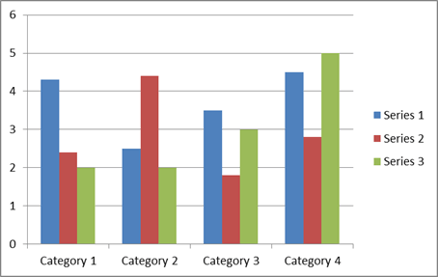
Figure 1: xxxx
(TNR, 11, CENTRE, CAPITAL EACH WORD)

REFERENCES (TNR, 11, BOLD, UPPER CASE)

APA format style (TNR, 11)

_____________________________________________________________________________________

STANDARD FORMAT

Times New Roman, 11, Single Spacing

Authors Guidelines;

- The article strictly in English
- Abstract (not more than 150 words)
- Journal (maximum 10 pages including references)
- Proceeding (maximum 15 pages including references)
- NO footnote.

Guidelines for Submission of Article
As part of the submission process, authors are required to check all of the following items, as submissions may be returned to authors that do not adhere to these guidelines.

Table 2: Submission Preparation Guidelines
Item | Description
File Format | - The submission file must be in Microsoft Word file format and send via Confbay.  - Other formats will be rejected.
Submission Rules | - Author is responsible to ensure paper submitted has not been previously published.  - Author is responsible to ensure paper submitted must not be under consideration for publication in another journal.
Originality | - The acceptable similarity index is below 30% including references and appendices.  - Work from other publications must be appropriately cited or quoted.  - Author is responsible to submit Similarity Index Report (Turnitin) together with full paper.
Copyright and confidentiality | - Author is responsible to ensure that his or her submitted works do not infringe any existing copyright.  - Author is also responsible to protect the anonymity and confidentiality of the respondents or to obtain letters of permission from the respondents if such anonymity and confidentiality are to be compromised.  - Author is responsible to submit the consent form given.

For any queries, kindly email to icbm@unimel.edu.my for assistance.

