TITLE SINERGY FOR SUSTAINABILITY: EMPOWERING TOURISM STAKEHOLDERS TO ACHIEVE THE SDGs
(Times New Roman/TNR 14)

Author^{1*}, Author², Author³
¹Name of Department, University, Country (TNR 11)
²Name of Department, University, Country
³Name of Department, University, Country
^{1*}Email, ²Email, ³Email

Article History: Received,,, 2024; Revised,,,, 2024; Accepted,,, 2024

Abstract: The abstract is to be in fully justified italicized text as it is here, below the author's information. Use the word “Abstract” as the title, in 11-point Times New Roman, boldface type, initially capitalized. The abstract is to be in 11-point, single-spaced type and may be up to 3 in. (18 picas or 7.62 cm) long. Leave two blank lines after the abstract, and then begin the main text. An abstract must be in English, including manuscripts other than in English. An abstract must contain the purpose of the study, Methodology, Main Findings, and Novelty/Originality of the study.

Keywords: 5 keywords, comma between keywords.

- INTRODUCTION
Congratulations! Your paper has been accepted for conference proceeding. Please follow the steps outlined below when submitting your final draft to the. These guidelines include complete descriptions of the fonts, spacing, and related information for producing your proceedings manuscripts. Please follow them and if you have any questions, direct them to the production editor in charge of your journal at the (Syafa’at, 2013).

- METHODOLOGY
All printed material, including text, illustrations, and charts, must be kept within the parameters of the 8 15/16-inch (53.75 picas) column length and 5 15/16-inch (36 picas) column width. Please do not write or print outside of the column parameters. Margins are 3.3cm on the left side, 3.65cm on the right, 2.03cm on the top, and 3.05cm on the bottom. Paper orientation on all pages should be in portrait style (Muthoifin, 2020).

- RESULTS AND DISCUSSION
The main title (on the first page) should begin 1 3/16 inches (7 picas) from the top edge of the page, centred, and in Times New Roman 14-point, boldface type and UPPERCASE (Suwito et al., 2022).

Tables
Place tables as close as possible to the text they refer to and align the centre. A table is labelled Table and given a number (e.g., Table 1. Icemat) it should be numbered consecutively. The table label and caption or title appear 11pt space above the table, and 6pt space after the text or paragraph if any; it should be uniform fonts and font size, and use 11pt font size and Helvetica style, capitalized similarly to the paper title, aligned centre and boldface. Sources and notes appear below the table, aligned left. All tables must be in portrait orientation (Muttaqin, 2014).
Table 1. Table Label
No
1
2
3
4

Figures
Place figures as close as possible to the text they refer to and align the centre. Photos, graphs, charts or diagrams should be labelled Figure (do not abbreviate) and appear 6pt space below the figure, 11pt space before the next text or paragraph, and assigned a number consecutively. The label and title should be in line with the figure number (e.g., Figure 1. Icemat), it should be uniform fonts and font size; use 11pt font size and Helvetica style, capitalized similarly to the paper title, aligned centre and boldface. Source (if any) appears underneath, flush left. Figures should be of good enough quality. Minimum image dimensions are 6 cm (2.3622 in) wide by 6 cm (2.3622 in) high (Nashir et al., 2019).
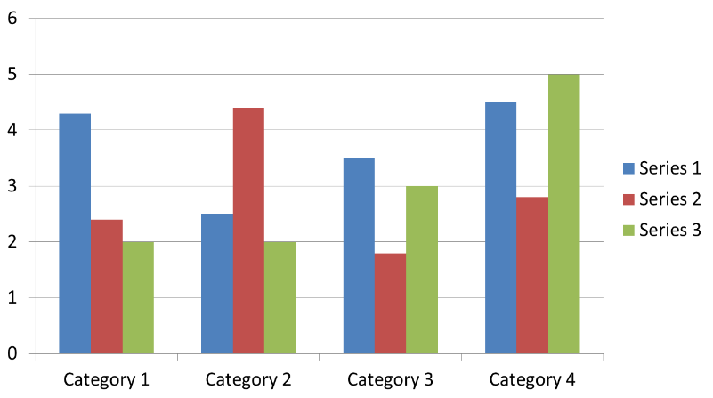

Figure 1. Figure Label

Figure 2. Icemat
Equations
Including symbols and equations in the text, the variable name and style must be consistent with those in the equations. Equations should be indented at the left margin and numbered at the right margin, The equation number is enclosed with open and close parenthesis () Time New Roman in style and 11pt font size. Deﬁne all symbols the first time they are used. All equation symbols must be defined clearly and understandably (Wekke et al., 2018).

FIRST-ORDER HEADINGS
For example, “INTRODUCTION”, should be in Times New Roman 12-point boldface, UPPERCASE, flush left, with one blank line before, and one blank line after.

Second-order Headings (Sub-heading)
As in this heading, they should be in Times New Roman 12-point boldface, initially Capitalized, flush left, with one blank line before, and one after.

Third-order Headings:
Third-order headings, as in this paragraph, are discouraged. However, if you must use them, use 11-point Times New Roman, boldface, initially Capitalized, flush left, and proceed by one blank line, followed by a colon and your text on the same line (Sofyan, 2015).
It should be noted, that manuscripts other than English can adapt this template.
Any comments and suggestions are welcomed so that we can constantly improve this template to satisfy all authors’ research needs.

- Theoretical and/or Practical Contribution

- Conclusion

REFERENCES (APA SYALE 6th EDITION)
List and number all bibliographical references that have important contributions to the paper, (if possible, limit to 30, which only are necessary citations are recommended). 9-point Times New Roman, fully justified, single-spaced, at the end of your paper. When referenced in the text, enclose the citation number in square brackets, for example (Sofyan, 2015). Do not abbreviate the months. Don’t forget to put the period (.) at the end of each reference. (See examples below). Do not use the phrases "et al." and "ibid." in the references section. Instead, the names of all authors in a reference must be listed. References must use the Mendeley system. With the numerical system, references are arranged in the reference list so that they match the order in which they are cited in the text.

Muthoifin, Nur Hanif Wachidah, R. A. R. (2020). Contribution of Kartini’s Thought on Women Education. Humanities & Social Sciences Reviews, 8(2), 143–150.
Muthoifin, B. P. (2020). Readiness Towards Halal Tourism in Indonesia Perspective of Reality and Religion. International Journal of Advanced Science and Technology, 29(8), 862–870.
Muttaqin, A. (2014). From occultism to hybrid Sufism: The transformation of an Islamic-hybrid spiritual group in contemporary Indonesia. Indonesian Journal of Islam and Muslim Societies, 4(1), 81–104. https://doi.org/10.18326/ijims.v4i1.81-104
Nashir, H., Jinan, M., & Setiaji, B. (2019). Muhammadiyah: the Political Behavior of Modernist Muslim Elite in Indonesia. Humanities & Social Sciences Reviews, 7(4), 837–844. https://doi.org/10.18510/hssr.2019.74111
Sofyan, R. (2015). Wonderful Indonesia Muslim Friendly Destination.
Suwito, S., Novianti, I., Suparjo, S., Widaputri, C. A., & Nuha, M. ’Azmi. (2022). Hybrid Sufism for enhancing quality of life: Ethnographic perspective in Indonesia. HTS Teologiese Studies / Theological Studies, 78(4), 1–8. https://doi.org/10.4102/HTS.V78I4.7198
Syafa’at, A. K. (2013). Potensi Zakat, Infaq, Shodaqoh Pada Badan Amil Zakat Nasional (BAZNAS) Di Kabupaten Banyuwangi Abdul. Journal of Chemical Information and Modeling, 53(9), 1689–1699. https://doi.org/10.1017/CBO9781107415324.004
Wekke, I. S., Ashrori, M., & Hamuddin, B. (2018). Institutional Transformation of Madrasa of Muslim Minority in Thailand. Jurnal Pendidikan Islam, 4(1), 15. https://doi.org/10.15575/jpi.v4i1.1961

