- Format Abstract / Full Paper Template
Helping Attitude among Startups: A Study on TUBE Mega 5.0 Participants
Author Names 1
Author Names 2
Authors’ Institutions
Faculty of Economics and Muamalat, Universiti Sains Islam Malaysia

Abstract
Helping others is considered and sometimes expected to be a voluntary act. This behavior can be characterized as a helpful behavior that does not expect something in return. In general, the behavior of helping others would create a conducive environment especially when being instilled at an early stage of entrepreneurial journey. The study was conducted on 115 startup companies owners who participated under Tunas Usahawan Belia Bumiputera (TUBE 5.0) organized by SME Corporation, an agency under the Ministry of International Trade and Industries, Malaysia in early March 2018. The rate of return on the questionnaires was 48%. The objective is to find and compare the helping attitude of startups based on several demographic factors. The sample was selected through purposive sampling technique. The researchers used the Helping Attitude Scale (HAS) by Gary S. Nickell. It is a scale with 20-item to measure respondents’ belief, feelings, and behaviors associated with helping others. The data was analyzed using Cross tabulation analysis. Based on the simple analyses, it is revealed that male startup owners possess better helping attitude than their female counterparts. Further analysis might give the researchers and the audience a better understanding and insights on this issue.

Keywords: Startups; Helping Attitude Scale; TUBE;

International Conference on Economics, Entrepreneurship and Management
2019 (ICEEM2019)
Langkawi July 6, 2019

PAPER'S TITLE:
Full First Author¹, Full Second Author², * and Full Third Author³
¹Full affiliation of first author, including country
²Full affiliation of second author, including country
³List all affiliation
*Authors’ email
Abstract. Here write the abstract - 200 – 250 words Abstract should outline the purpose of the article, method of the research, data and main results.

Keywords: key word, key word, key word (max 5 key words in English)

1. Introduction (TNR 14pt., bold)
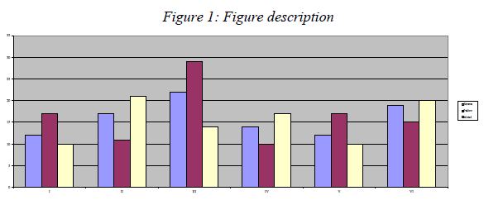
The main text¹

Source:
Text, text, text, text, text, text, text, text, text, text, text, text, text, text, text, text, text, text, text, text, text, text, text, text, text, text, text, text.
1.1 Title of the 2nd level
Text, text, text, text, text, text, text, text, text, text, text, text, text, text, text, text, text, text, text, text, text, text, text, text, text, text, text, text, text, text, text, text, text, text, text, text, text, text, text, text, text, text, text, text, text, text, text, text, text, text.

1.1.1 Title of the 3rd level
Text, text, text, text, text, text, text, text, text, text, text, text, text, text, text, text, text, text, text, text, text, text, text, text, text, text, text, text, text, text, text, text, text, text, text, text, text, text.
Tables and figures should be numbered and references to them must be in the text. Acceptable labeling for a table is Tab.1 and Fig. 1 for a figure.
Table 1: Table description (TNR 10pt., italics)
__________________________
¹ Footnote TNR 10pt
International Conference on Economics, Entrepreneurship and Management
2019 (ICEEM2019)
Langkawi July 6, 2019

Times New Roman 10pt | Times New Roman 10pt | Times New Roman 10pt
Times New Roman 10pt | Times New Roman 10pt | Times New Roman 10pt
Times New Roman 10pt | Times New Roman 10pt | Times New Roman 10pt
Times New Roman 10pt | Times New Roman 10pt | Times New Roman 10pt
Source:
Equations

Equations (refer with: Eq. 1, Eq. 2,...) should be placed in the middle, denoted by numbers in round parentheses and transformed by equation conversion manager, do not use Print Screen or jpg format. For example:

( ), ri − rf = βi rM − rf i =1,2,....,n (1)

2. Body of paper

The article must be divided into chapters. Introduction and conclusion are obligatory. It is recommended to adjust body of the paper to the common organization structure of scientific papers – IMRaD (Introduction, Methods, Results and Discussion).

Conclusion Acknowledgment (TNR 12pt. bold)
This paper is an output of the science project…

References

For each work shown in the list of references must be a reference in the text. All citations in the text and all references must meet APA styles (American Psychological Association 6th edition – more information http://www.apastyle.org/).

