TITLE OF FULL PAPER

Ahmad Abrar Amir¹, Annur Awatif Ali²
¹Agrotechnology and Bio-Industry Department, Politeknik Sandakan Sabah
²Civil Engineering Department, Universiti Putra Malaysia, Selangor

¹Corresponding author’s email: abrar@pss.edu.my
ABSTRACT
The abstract should be typed single-spaced in 10-points Times New Roman and 250 - 300 words. The abstract should not only indicate the subject and scope of the paper but also summarize the author’s conclusion. The structured abstract must be a brief, comprehensive summary of the article’s contents. It allows readers to survey the contents of an article quickly. An abstract summarizes the significant aspects of a paper. It should briefly summarize the paper’s purpose, methods, significant results, and conclusions. (*Font: 10; Single spacing; Times New Roman)
Keywords: One; Two; Three (maximum of three keywords)
--------------------------------------------------------------------------------------------------------------------------------------

- Introduction
Should discuss the problem statement, the background of the study, the contribution, the research objective and the question in paragraph form. The summary of paper structure also should be briefly discussed. The subtopic must be written as follows:

1.1 Agent B Theory
They are called ….

1.1.1 Round Robin effects
Some of the researchers ….

- Literature review
Discuss about the empirical arguments thoroughly, don’t forget to cited strong arguments, and discuss the hypothesis in here. ﻿

H3. The monitoring effectiveness of female corporate leaders is more pronounced during the anti-corruption campaign period.

- Methodology
Define abbreviations and acronyms the first time they are used in the text, even after they have been defined in the abstract.
- Discussion of analysis and findings
The equation must be labelled following below:
Model equation is written as:
Y = mX + C ….. [1]
The diagram/graph/table/picture must be labelled at the bottom of it. All table must be paste in editable format. DO NOT PASTE TABLE IN A PICTURE FORMAT.

Model A | Model B | Model C
Table 1.1: Result for each model

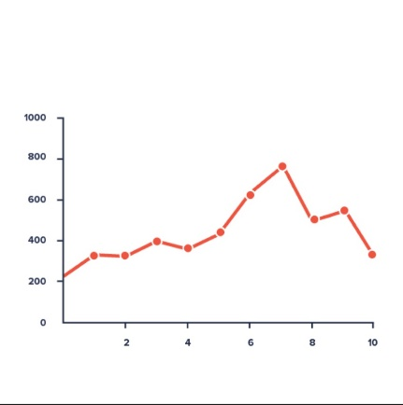
Figure 1.1: Stock price fluctuation

- Conclusion and future research
Briefly discuss the issue, the argument you expected to be and the main findings. No table/graph/diagram is allowed here. Also discuss about the limitation and recommendation for future research.

Acknowledgment
The preferred spelling of the word “acknowledgment” in America is without an “e” after the “g.” Avoid the stilted expression “one of us (X. Y. Z.) thanks ...”. Instead, try “X. Y. Z. thanks...”. Put sponsor acknowledgments in the unnumbered footnote on the first page.

References
Use the APA Referencing Style 6th edition for the references. The pdf file for “A Guide to APA Referencing Style: 6th Edition” can download by using this link
Example:
Waliuddin, M., Razali, M., Fui, W. Y., Shaharuddin, S., Tak, A. H., Uzairi, M., & Hajazi, A. (2017). Corporate Social Responsibility Disclosure and Cost of Equity Capital in Industrial. Journal of Humanities, Language, Culture and Business, 1(2), 168–180.

