TITLE OF PAPER
[Title: uppercase, Times New Roman, font size 12, centered]

Author Name^{1*}, Author Name² & Author Name³
[Use full name of all authors, Times New Roman, font size 10, superscript 1, 2, 3 etc. to indicate affiliation, centered]

¹Fakulti Perladangan dan Agroteknologi, Universiti Teknologi MARA, Kampus Jasin,77300, Melaka, Malaysia
²Faculty of Science, Computer and Mathematic, Universiti Teknologi MARA, Kampus Jasin,77300, Melaka, Malaysia
³Faculty of Information Management, Universiti Teknologi MARA , Campus Puncak Perdana, 40150 Shah Alam, Selangor, Malaysia [Indicate authors’ affiliation with superscript 1, 2, 3, etc. and start each address on new line, Times New Roman, font size 8, italic, centered]

*Corresponding author: email address [Times New Roman, italic, font size 8]
Abstract
The manuscript must include an abstract, describing its main points within 150-250 words in English. The abstract should encapsulate the research objective(s), the methodology and findings. Author should decide on his paper, fallen in which area of sub-theme conference like if it fallen in Emerging sustainable approach in plantation management and agribusiness, so his paper should write PMAXXX on top right corner of paper as indicated above. Other sub-theme for this 2nd IPC 2019 are Plantation crop productivity and management which should write AGRXXX, Sustainable crop protection in plantation (PROXXX), Sustainable management of marginal soil for future plantation (SOIXXX), Sustainable agricultural engineering through automation, smart and precision technology in plantation (ABEXXX) and Biotechnology practices for sustainable plantation (BIOXXX). This requirement as indicator for reviewing process. Abstract should write in justify format.

Keywords: [3-5 words; Times New Roman; font size 9; arrange alphabetically]

Introduction
[All first order headings use Times New Roman, font size 10, bold and centered]
The manuscript should be typed with double spacing, double column and font size 10 on A4 paper not exceeding 5 pages. In general, the contents should comprise of Introduction, Materials and Methods, Results and Discussion, Conclusion, Acknowledgement and References. The manuscript should be supplied with 3-5 keywords.

Materials and methods
[Second order headings should be bold, font size 10, bold and centered]
Author should remember to write shortform on top right side of paper in which area of sub-theme. It are; Emerging sustainable approach in plantation management and agribusiness (PMAXXX), Plantation crop productivity and management (AGRXXX), Sustainable crop protection in plantation (PROXXX), Sustainable management of marginal soil for future plantation (SOIXXX), Sustainable agricultural engineering through automation, smart and precision technology in plantation (ABEXXX) and Biotechnology practices for sustainable plantation (BIOXXX)

Results and discussion
All illustrations including figures, charts and graphs must be labelled and supplied on pages together with the text. The desired placement in the text should be clearly indicated. These illustrations should be referred to and numbered serial, as figures (Figure 1). All illustrations should be clearly drawn in permanent ink or photographed in sharp black and white and reproduced in the form of high – contrast glossy prints or digital images and provided in camera ready form. References in the text should be denoted by giving the name(s) of the author(s). All alphabetically ordered references list should be included at the end of the manuscript. All references cited in the text must appear in the reference list. Authors are responsible for the accuracy and completeness of all information in the reference. The references style adopted should be consistent throughout the manuscript (Mohammad et al. 2018; Nashriyah et al. 2014; Shuib and Deraman 2010).

Table 1. [Table text and caption should centered, Times New Roman, font size 10, included in body text]

 | Title 2 | Title 3 | Title 4 | Title 5 | Title 6
A
B
C

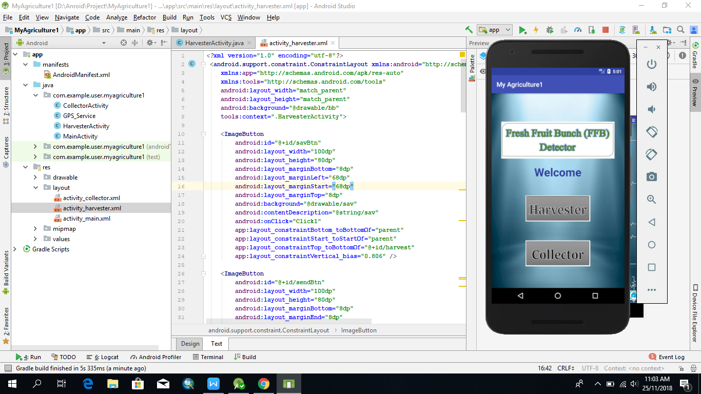
Figure 2; Test run the developed applications using emulator that available in the android studio software.

Figure 1. [illustration text and caption should centered, font size 1o, included in body text]

Conclusion
It is the author’s responsibility to ensure that his or her submitted work does not infringe any existing copyright. Manuscripts will be reviewed by the Editorial Board and at least one independent referee. Decisions regarding the acceptance of a manuscript will be based on the reviewer’s recommendations. The manuscript will be evaluated based on its appropriateness for conference theme, cogency of analysis, conceptual breadth, clarity of presentation and technical adequacy.

Acknowledgements
This template gives formatting guidelines for authors preparing papers for proceeding publication in the 2nd International Plantation Conference 2019. The authors must follow the instructions given in the document for the papers to be published.

References
Mohammad Hudzari Haji Razali, Mohamad Noorman Masrek and Mohamad Fauzi Md Said,(2018) Internet of Thing (IOT) for Agriculture Technology Development, The 2018 Annual Conference of Malaysia Society Of Agricultural Engineers, 6-7 Februari 2018, Serdang, Selangor
Nashriyah Mat, Razali Mohd. Hudzari and Khandaker,
Mohammad Moneruzzaman (2014) Effects of Irrigation Frequencies on Aerial Agro-Morphological Parameters of Dioscorea hispida Dennst. (Dioscoreaceae). Journal of Applied Sciences Research 8 (9): 27-37.
Shuib, A. R., Khalid, M. R. & Deraman M. S., (2010). Enhancing Field Mechanization in Oil Palm Management. Oil Palm Bulletin 61(1):1-10.

