TITLE (TNR, 16, CENTER, UPPERCASE)

Author (TNR, 12, Bold, Centre, Capitalize Each Word) ¹

¹Author details (TNR, 10,)

__________________________________________________________________________________________

Abstract: (TNR, 12, italic, single spacing).

Keywords: (TNR, 12, single spacing)

Introduction (TNR, 12, bold, align left)

Tourism in rural areas plays an important role …… (TNR, 12, single spacing, justify)

Literature review (TNR, 12, bold, align left)
Definition and concepts of rural tourism (TNR, 12, bold, italic, align left)

In particular, Irshad (2010)’s review of Page and Getz (1997)……. (TNR, 12, single spacing, justify)
Rural Tourism (TNR, 12, bold, italic, align left)
As mention by Irshad (2010)’s ……… (TNR, 12, single spacing, justify).
Table 1: Example (TNR, 10, single spacing, bold, centre)
Example | Example | Example
Example | Example | Example
Example | Example | Example

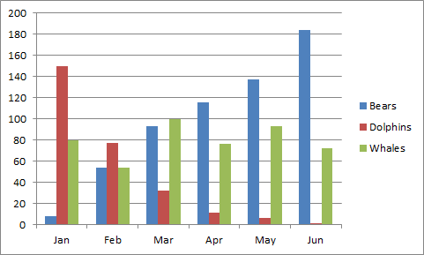
Figure 1: Example (TNR, 10, single spacing, bold, centre)

References (APA Sixth Edition) – 15 references (Minimum)
Criteria for Best Paper Award:

* The paper is an Empirical Paper
* Number of pages 6 – 15 pages
* Minimum number of reference are 15
* Submit paper before 23 June 2018

