SAMPLE MANUSCRIPT SHOWING STYLE AND FORMATTING SPECIFICATIONS FOR JIMF (NO MORE THAN 12 WORDS IN CALIBRI)

First Author
Second Author

Abstract

The abstract should consist of a single paragraph containing no more than 350 words (in english). It should be a summary of the paper and not an introduction. Because the abstract may be used in abstracting and indexing databases, it should be self-contained (i.e., no numerical references) and substantive in nature, presenting concisely the objectives, methodology used, results obtained, and their significance. A list of up to six keywords should immediately follow, with the keywords separated by commas and ending with a period.

Keywords: Investment Account Platform, Financing, Investment (min.3 words)
JEL Classification: E22, G24, M13, M14 (min. 3 JELs)

INTRODUCTION (CALIBRI 12)
Including Background and Objective.
Massive capital inflow leads to appreciation.... (Calibri 11)

LITERATURE REVIEW (CALIBRI 12)

2.1 Theory – e.g. Modern Portfolio Theory (Calibri 11.5)
Modern Portfolio Theory is a mathematical formulation (Calibri 11)

Sub-subsection (Calibri 11)

2.2 Previous Sudies (Calibri 11.5)
The following Figure 1 depicts the illustration of how the IAP has been structured in Malaysia. Basically, the source of fund comes from various parties such as individual, corporate. Usually they will channel fund to the projects or ventures that they have chosen. (Calibri 11)
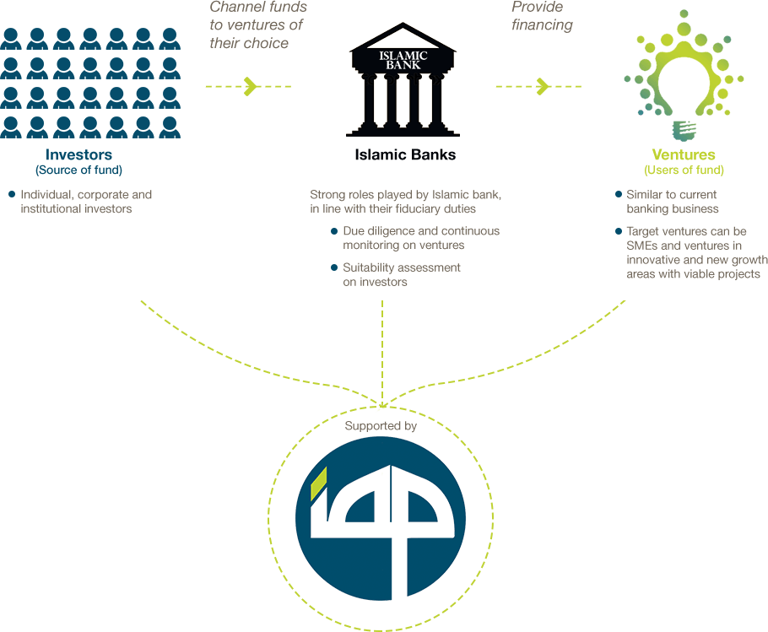
Figure 1.
Operationalization of IAP (Calibri 11)
Source: https://www.iaplatform.com/ (Calibri 9)

METHODOLOGY

3.1 Data (Calibri 11.5)
Data of this study consists of … (Calibri 11)

3.2 Method or Estimation Technique (Calibri 11.5)
Ordinary linear regression model emphasizes ... (Calibri 11)

3.3 Empirical Model (Calibri 11.5)
The behavioural intention of investors to using Investment Account Platform (IAP) was tested by using Structural Equation Modeling (SEM).
Table 1.
Distribution of Respondents by Gender, Age and Marital Status (Calibri 11)
In table text (Calibri 10) |  | Frequency | %
Gender | Male | 433 | 43.3
 | Female | 567 | 56.7
Age Group | 20-30 | 583 | 58.3
 | 31-40 | 213 | 21.3
 | 41-50 | 147 | 14.7
 | Above 50 | 57 | 5.7
Marital Status | Single | 572 | 57.2
 | Married | 401 | 40.1
 | Divorced | 27 | 2.7
Educational Level | No Education | 22 | 2.2
 | Secondary School | 146 | 14.6
 | Diploma | 176 | 17.6
 | Bachelor | 588 | 58.8
 | Postgraduate (Master or PhD) | 68 | 6.8
Occupational | Public | 169 | 16.9
 | Private | 272 | 27.2
 | Self employed | 82 | 8.2
 | Housewife | 39 | 3.9
 | Student | 415 | 41.5
 | Retired | 23 | 2.3
Income Level | Less than RM1000 | 307 | 30.7
 | RM1001- RM2000 | 168 | 16.8
 | RM2001- RM3000 | 144 | 14.4
 | RM3001- RM4000 | 130 | 13
 | RM4001- RM5000 | 105 | 10.5
 | More Than RM5000 | 146 | 14.6

RESULT AND FINDING

4.1 Structural Equation Modelling

4.1.1 Measurement Model

The initial measurement model incorporates three latent constructs indicated by respective items pertaining to each scale: perceived usefulness (PU), perceived easy to use (PEU) and behavioural intention (BI) (see Figure 3 for the initial measurement model). The results of goodness-of-fit indices for the initial measurement model are given in the following Table 2.
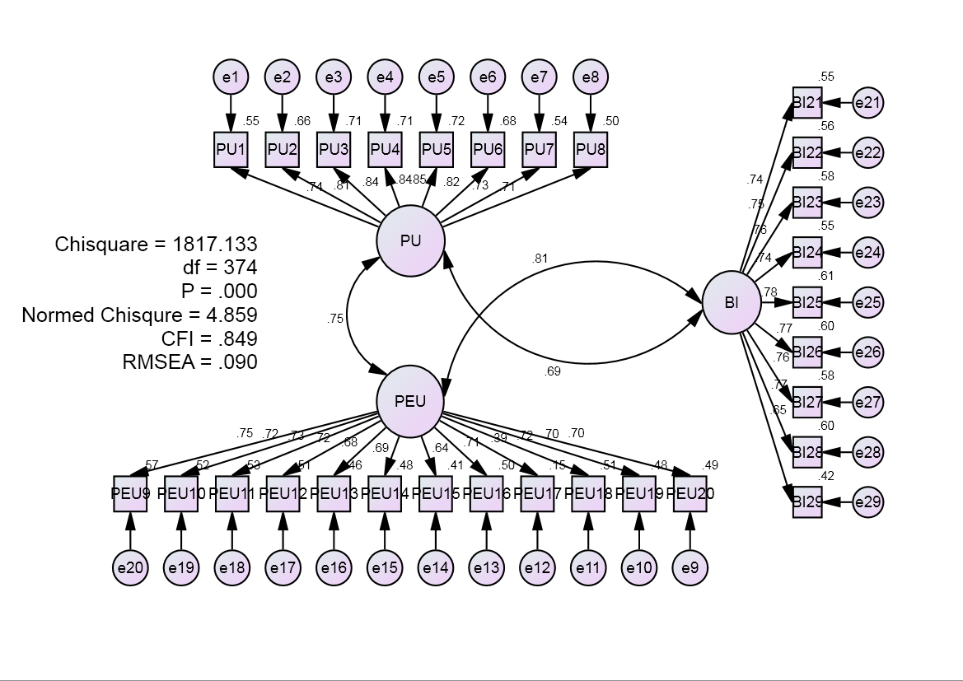
Figure 3.
Initial Measurement Model (MM1)

CONCLUSION
The findings of this study can be used to develop a specific framework in which to examine other components of using Investment Account Platform (IAP)’s behavior and to plan appropriate intervention strategies to increase its capacity in assisting SMEs to access to external finance in Malaysia.

REFERENCES
The References section lists books, articles, and reports that are cited in the paper. References to other publications must be in APA style and carefully checked for completeness, accuracy and consistency using Mendeley.
(a) Books
Chapra, M. U. (2010). Islamic perspective on poverty alleviation. Jeddah: Islamic Research and Training Institute.
Romer, D. (2006). Advanced macroeconomics (3rd ed.). New York: MC Graw-Hill.

(b) Journal Article
Iqbal, Z., & Mirakhor, A. (2012). Financial inclusion: Islamic finance perspective. Journal of Islamic Business and Management, 2(1), 35-64.
Abbasi, M.S., Chandio, F.H., Soomro, A.F., & Shah, F. (2011). Social Influence, Voluntariness, Experience and The Internet Acceptance: An Extension Of Technology Acceptance Model Within A South-Asian Country Context. Journal of Enterprise Information Management, 24(1), 30-52.

(c) Chapters in edited books
Evans, T. (1997). Democratization and human rights, In A. McGrew (Ed.), The transformation of democracy? (pp. 122-148). Cambridge: Polity Press.

(d) Conference Paper/Proceeding
Cizakca, M. (2004, March). Cash waqf as alternative to NBFIs bank. Paper presented at The International Seminar on Nonbank Financial Institutions: Islamic Alternatives, Kuala Lumpur.

(e) Research Report
Firdaus, M., Beik, I. S., Irawan, T. & Juanda, B. (2012). Economic estimation and determinations of zakat potential in Indonesia (Working Paper Series WP 1433-07). Jeddah: IRTI.
Wimanda, R. E. (2010). Inflation and monetary policy rules: evidence from Indonesia (Doctoral Thesis). Loughborough University.

(f) Newspaper
Cowan, R. (2001, October 23). Adams asks IRA to disarm. The Guardian, p.1.

(g) Website material
Asian Development Bank Institute. (2014). Financial inclusion in Asia: Country survey. Tokyo: Author. Retrieved December 4, 2015, from http://www.adb.org/sites/default/files/publication/159308/adbi-financial-inclusion-asia.pdf

NOTES TO CONTRIBUTORS
SUBMIT TO THE JOURNAL
Papers to be submitted should be written in English between 6000 and 11000 words. The articles submitted to the Journal of Islamic Monetary Economics and Finance should be original contributions and should not be under consideration for any other publication at the same time. Manuscripts must be submitted electronically in MS Word format to the website, http://journalbankindonesia.org/index.php/JIMF/index, cc to jimf@bi.go.id and journal.jimf@gmail.com. Articles must be typewritten, double-spaced and with ample margins and all pages (including those containing any diagrams and tables) must be numbered consecutively. Arabic numerals are to be used throughout.
REVIEW PROCESS
Each paper is reviewed by the editor and, if it is judged suitable for this publication, it is then sent to at least two independent referees for double blind peer review.
COPYRIGHT AND COPYRIGHT TRANSFER
Articles submitted to the journal should not have been published before in their current or substantially similar form, or be under consideration for publication with another journal. Authors submitting articles for publication warrant that the work is not an infringement of any existing copyright and will indemnify the publisher against any breach of such warranty.
The editor may make use of iThenticate software for checking the originality of submissions received.
For the copyright transfer, all author and co-author signatures must be original. Proxy signatures are not acceptable (that is, authors cannot sign on behalf of others). All author and co-author signatures must be secured. All authors need not sign the same form.
Sign the Copyright Transfer Form (attachded) and please send it to the email journal.jimf@gmail.com.

SUBMISSION CHECKLIST
As part of the submission process, authors are required to check off their submission's compliance with all of the following items, and submissions may be returned to authors that do not adhere to these guidelines.
  - Author Statement of copyright transfer (attached);
  - The article with all tables and figures in Microsoft Word file format;
  - Abstract 150-350 words (with maximum 4 keywords and 4 JEL classification);
  - The text is 1.15 spaced; Use Calibri font throughout the manuscript;
  - Biography for each author;
  - The reference should be made using APA styles through Mendeley.

Should you have any quiries regarding this journal, please contact:

Journal of Islamic Monetary Economics and Finance

Published by Islamic Economic and Finance Department,
Bank Indonesia
C Building, 3rd Floor
JI. M. H. Thamrin No. 2, Jakarta 10350, Indonesia
Phone: +62-21-29817345; Fax: +62-21-2311128
Email: jimf@bi.go.id; journal.jimf@gmail.com

http://www.journalbankindonesia.org/index.php/JIMF

Affiliation and Correspondence Email
Affiliation and Correspondence Email

