Title of the paper (14pt Times New Roman, Centred)
Leave one blank
Margins 1.8 cm
Margins 1.8 cm
Margins 2.5 cm

AUTHOR’S NAME (Capital, 12pt Times New Roman, centred)
University (12pt Times New Roman, centred)
Leave one blank

AUTHOR’S NAME (Capital, 12pt Times New Roman, centred)
University (12pt Times New Roman, centred)
Leave two blanks

ABSTRACT (Capital, 12pt Times New Roman, Italics)
Leave one blank

This is a sample of the format of your paper. A minimum of 10 A4-sized pages (21 x 29.7cm) pages with top and margins of 2.5cm and left and right margins of 1.8 cm. Use single space, 10 pt size Times New Roman throughout the paper.
Leave one blank

Keywords: Leave one blank line after the abstract and write your keywords (max 5)
Leave two blanks

ABSTRAK (Capital, 12pt Times New Roman, Italics)
Leave one blank

Abstract must be written in both English and Malay language
Leave one blank
.

Kata Kunci: Leave one blank line after the abstract and write your keywords (max 5)
Leave two blanks

INTRODUCTION (Capital, 12pt Times New Roman)
Leave one blank

In general, the contents of the paper should comprise of Introduction, Literature Review, Methodology, Results and Discussion, Conclusion, Acknowledgement and References.
Leave two blanks

METHODOLOGY (Capital, 12pt Times New Roman)
Leave one blank

Explain how the research is conducted
Leave two blanks

LITERATURE REVIEW (Capital, 12pt Times New Roman)
Leave one blank

Explain past studies and the gaps that lead to this research
Leave two blanks

RESULTS AND DISCUSSION (Capital, 12pt Times New Roman)
Leave one blank

SECTION (Capital, 11pt Times New Roman)
Leave one blank

SUB-SECTION I (Capital, 10pt Times New Roman)
Leave one blank

SUB-SECTION II (Capital, 10pt Times New Roman)
Leave two blanks

CONCLUSION (Capital, 12pt Times New Roman)
Leave one blank

Conclude and summarise the findings
Leave two blanks

ACKNOWLEDGEMENT (Capital, 12pt Times New Roman)
Leave one blank

Please provide the details of the research grant that is supporting the research
Leave two blanks

REFERENCES (Capital, 12pt Times New Roman)

Chamhuri, S., Mahmudul, A., Wahid, M. and Al-Amin. 2009. Climate Change, Agricultural Sustainability, Food Security and Poverty in Malaysia. IRBRP J.,5 (6): 309-321

Choong, L. 2000. Report 3: Assessment of the Impacts of Climate Change on Key Economics Sector in Malaysia. Kuala Lumpur: National Meteorological Service.

Combest-Friedman, C., Christie, P. and Miles, E. 2012. Household perceptions of coastal hazards and climate change in the central Philippines. Journal of Environmental Management, Vol. 112 (December). 137-148.

Confalonieri, U., Menne, B., Akhtar, R., Ebi, K.L., Hauengue, M., Kovats, R.S., Revich, B. and Woodward, A. 2007. Human Health Climate Change 2007: Impacts, Adaptation and Vulnerability, in Parry, M.L., Canziani, O.F., Palutikof, J.P., van der Linden, P.J. and Hanson, C.E. (Eds), Contribution of Working Group II to the Fourth Assessment Report of the Intergovernmental Panel on Climate Change. Cambridge: Cambridge University Press. 391-431.

Department of Irrigation and Drainage Malaysia. 2012. Coastal management – activities, available at: www.water.gov.my/our-services-mainmenu-252/coastal-managementmainmenu-279/activities-mainmenu-184 (accessed 20 December 2016).

REFERENCE CITATIONS
- All entries in the reference list must be citied in text using the author-date method [e.g., Adams (1999).
- If a work has two authors, always cite both names every time the work is referred to in the text.
- If a work has three to five authors, cite all authors the first time the reference occurs; in subsequent citations, include only the name of the first author followed by “et al.” and the year.
- For works with six or more authors, use only the name of the first author followed by “et al.” and the year whenever the work is cited (in the reference list, however all names must be given).
- Pages number should be provided when specific arguments or findings of authors are paraphrased, summarized, or directly quoted. Examples :
First citation in text
Lim, Ahmad and Bricks (2003) found …….
Subsequent citations
Lim et al. (2003) found ……
- For parenthetical citations of two or more works, use alphabetical ordering and ampersands (&). Separate each cited work by semicolons except for multiple works by the same authors separated by comas. Example:
Several researchers (e.g., Bushee 2001; Darrough & Rangan 2004, 2010; Norman & Kamran 2005; Shen & Chih 2005; Woidtke 2002) supported this argument.

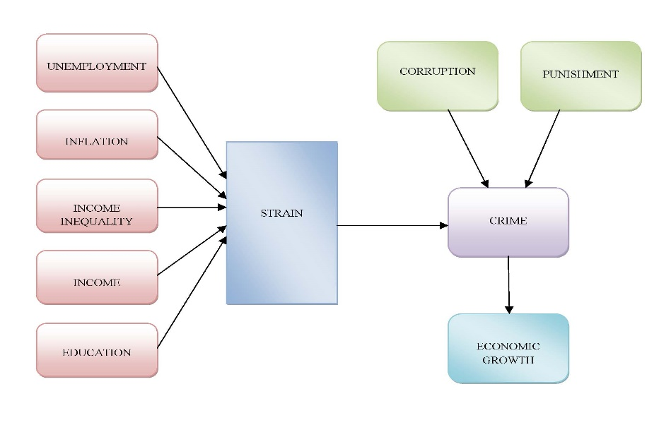

FIGURE 1. Interrelation between Socio and Macroeconomic Variables and Crime
Source : N/A

TABLE 1. Pearson Correlation matrix among variables
 |  | Encouragement | Competency | Governance
 | Readiness | 0.0123 | 0.550 | 0.610
 | Competency |  | 1.000 | 0.058
 | Governance |  |  | 1.000

Source : N/A

