TITLE (TNR, 16, CENTER, UPPERCASE)

First A. Author*¹, Second B. Author2 and Third C. Author3

¹ Authors’ Department, Institute, City, Country.
(E-mail: firstauthorsname@abcd.wxyz)
² Author’s Department, Institute, City, Country.
(Email: secondauthorsname@abcd.wxyz)
³ Author’s Department, Institute, City, Country.
(E-mail: thirdauthorsname@abcd.wxyz)

___________________________________________________________________________

Abstract: The abstract should not more than 300 words each. The abstract should not only indicate the subject and scope of the paper, but also summarize the author’s conclusion. Structured abstract must be a brief, comprehensive summary of the contents of the article. It allows readers to survey the contents of an article quickly. An Abstract summarizes the major aspects of a paper. It should succinctly summarize the purpose of the paper, the methods used, the major results, and conclusions.

Keywords: Keyword 1, Keyword 2, Keyword 3 (Min 3 key words & Max 5 Key words)
___________________________________________________________________________

Introduction (TNR, 12, bold, align left)

Tourism in rural areas plays an important role …… (TNR, 12, single spacing, justify)

Literature review (TNR, 12, bold, align left)

Definition and concepts of rural tourism (TNR, 12, bold, italic, align left)

In particular, Irshad (2010)’s review of Page and Getz (1997)……. (TNR, 12, single spacing, justify)
Rural Tourism (TNR, 12, bold, italic, align left)
As mention by Irshad (2010)’s ……… (TNR, 12, single spacing, justify).
Table 1: Example (TNR, 10, single spacing, bold, centre)
Example | Example | Example
Example | Example | Example
Example | Example | Example

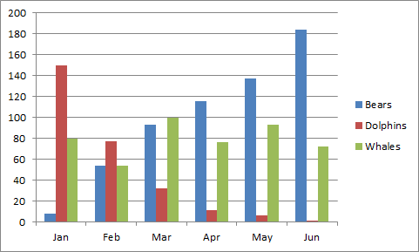
Figure 1: Example (TNR, 10, single spacing, bold, centre)

References (APA Sixth Edition)
The minimum are 15 references.
Criteria for Best Paper Award:

* minimum references are 15
* minimum 3pages and maximum 9pages
* empirical paper
* submit paper before 2-weeks conference

