Your Title Goes Here with Each Initial Letter Capitalized
First A. Author¹, Second B. Author², and Third C. Author³
¹Department of ......., University of ........., Address, City
²Institution/Company Affiliation, Address, City

Abstract—These instructions give you guidelines for preparing papers for The 1st International Conference on Invention & Design (ICID) 2016. Use this document as a template if you are using Microsoft Word 2003 or later. Otherwise, use this document as an instruction set. The electronic file of your paper will be formatted further at ICID 2016 Confrence Proceedings or any selected Scopus cited journal based on the theme tracks. Define all symbols used in the abstract. Do not cite references in the abstract. Do not delete the blank line immediately above the abstract; it sets the footnote at the bottom of this column.

Index Terms—About four key words or phrases in alphabetical order, separated by commas.

Introduction
Highlight a section that you want to designate with a certain style, then select the appropriate name on the style menu. The style will adjust your fonts and line spacing. Do not change the font sizes or line spacing to squeeze more text into a limited number of pages. Use italics for emphasis; do not underline.
To insert images in Word, position the cursor at the insertion point and either use Insert | Picture | From File or copy the image to the Windows clipboard and then Edit | Paste Special | Picture (with “Float over text” unchecked).
For publication purpose on the selected papers, the Scopus cited journal reserves the right to do the final formatting of your paper.

Procedure for Paper Submission

Review Stage
Submit your manuscript electronically for review.

Final Stage
When you submit your final version, after your paper has

been accepted, prepare it in two-column format, including figures and tables.

Figures
As said, to insert images in Word, position the cursor at the insertion point and either use Insert | Picture | From File or copy the image to the Windows clipboard and then Edit | Paste Special | Picture (with “Float over text” unchecked).
The authors of the accepted manuscripts will be given a copyright form and the form should accompany your final submission.

Math
If you are using Word, use either the Microsoft Equation Editor or the MathType add-on (http://www.mathtype.com) for equations in your paper (Insert | Object | Create New | Microsoft Equation or MathType Equation). “Float over text” should not be selected.

Units
Use either SI (MKS) or CGS as primary units. (SI units are strongly encouraged.) English units may be used as secondary units (in parentheses). This applies to papers in data storage. For example, write “15 Gb/cm² (100 Gb/in²).” An exception is when English units are used as identifiers in trade, such as “3½ in disk drive.” Avoid combining SI and CGS units, such as current in amperes and magnetic field in oersteds. This often leads to confusion because equations do not balance dimensionally. If you must use mixed units, clearly state the units for each quantity in an equation.
The SI unit for magnetic field strength H is A/m. However, if you wish to use units of T, either refer to magnetic flux density B or magnetic field strength symbolized as µ₀H. Use the center dot to separate compound units, e.g., “A·m².”

Helpful Hints

Figures and Tables
Because the final formatting of your paper is limited in scale, you need to position figures and tables at the top and bottom of each column. Large figures and tables may span both columns. Place figure captions below the figures; place table titles above the tables. If your figure has two parts, include the labels “(a)” and “(b)” as part of the artwork. Please verify that the figures and tables you mention in the text actually exist. Do not put borders around the outside of your figures. Use the abbreviation “Fig.” even at the beginning of a sentence. Do not abbreviate “Table.” Tables are numbered with Roman numerals.
Include a note with your final paper indicating that you request color printing. Do not use color unless it is necessary for the proper interpretation of your figures.
Figure axis labels are often a source of confusion. Use words rather than symbols. As an example, write the quantity “Magnetization,” or “Magnetization M,” not just “M.” Put units in parentheses. Do not label axes only with units. As in Fig. 1, for example, write “Magnetization (A/m)” or “Magnetization (Am⁻¹),” not just “A/m.” Do not label axes with a ratio of quantities and units. For example, write “Temperature (K),” not “Temperature/K.”
Multipliers can be especially confusing. Write “Magnetization (kA/m)” or “Magnetization (10³ A/m).” Do not write “Magnetization (A/m) × 1000” because the reader would not know whether the top axis label in Fig. 1 meant 16000 A/m or 0.016 A/m. Figure labels should be legible, approximately 8 to 12 point type.

TABLE I: The Arrangement of Channels
Channels | Group 1 | Group 2 | … | Group c
Main channel | Channel 1 | Channel 2 | … | Channel c
Assistant channel | Channel 2 | Channel 3 | … | Channel 1

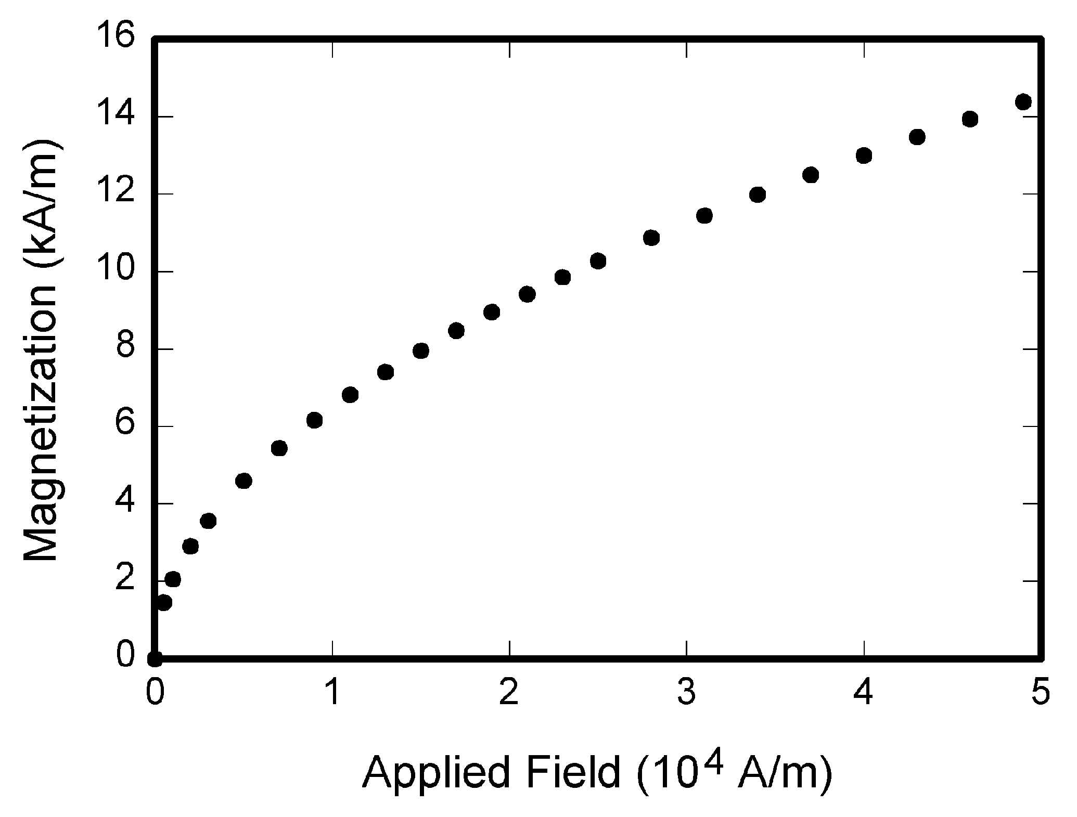
Fig. 1. Magnetization as a function of applied field.

References
Number citations consecutively in square brackets [1]. The sentence punctuation follows the brackets [2]. Multiple references [2], [3] are each numbered with separate brackets [1]–[3]. When citing a section in a book, please give the relevant page numbers [2]. In sentences, refer simply to the reference number, as in [3]. Do not use “Ref. [3]” or “reference [3]” except at the beginning of a sentence: “Reference [3] shows ... .” Number footnotes separately in superscripts (Insert | Footnote). Place the actual footnote at the bottom of the column in which it is cited; do not put footnotes in the reference list (endnotes). Use letters for table footnotes (see Table I).
Please note that the references at the end of this document are in the preferred referencing style. Give all authors’ names; do not use “et al.” unless there are six authors or more. Use a space after authors' initials. Papers that have not been published should be cited as “unpublished” [4]. Papers that have been submitted for publication should be cited as “submitted for publication” [5]. Papers that have been accepted for publication, but not yet specified for an issue should be cited as “to be published” [6]. Please give affiliations and addresses for private communications [7].
Capitalize only the first word in a paper title, except for proper nouns and element symbols. For papers published in translation journals, please give the English citation first, followed by the original foreign-language citation [8].

Abbreviations and Acronyms
Define abbreviations and acronyms the first time they are used in the text, even after they have already been defined in the abstract. Abbreviations such as SI, ac, and dc do not have to be defined. Abbreviations that incorporate periods should not have spaces: write “C.N.R.S.,” not “C. N. R. S.” Do not use abbreviations in the title unless they are unavoidable.

Equations
Number equations consecutively with equation numbers in parentheses flush with the right margin, as in (1). First use the equation editor to create the equation. Then select the “Equation” markup style. Press the tab key and write the equation number in parentheses. To make your equations more compact, you may use the solidus ( / ), the exp function, or appropriate exponents. Use parentheses to avoid ambiguities in denominators. Punctuate equations when they are part of a sentence, as in

(1)

Be sure that the symbols in your equation have been defined before the equation appears or immediately following. Italicize symbols (T might refer to temperature, but T is the unit tesla). Refer to “(1),” not “Eq. (1)” or “equation (1),” except at the beginning of a sentence: “Equation (1) is ... .”

Other Recommendations
Use one space after periods and colons. Hyphenate complex modifiers: “zero-field-cooled magnetization.” Avoid dangling participles, such as, “Using (1), the potential was calculated.” [It is not clear who or what used (1).] Write instead, “The potential was calculated by using (1),” or “Using (1), we calculated the potential.”
Use a zero before decimal points: “0.25,” not “.25.” Use “cm³,” not “cc.” Indicate sample dimensions as “0.1 cm × 0.2 cm,” not “0.1 × 0.2 cm².” The abbreviation for “seconds” is “s,” not “sec.” Do not mix complete spellings and abbreviations of units: use “Wb/m²” or “webers per square meter,” not “webers/m².” When expressing a range of values, write “7 to 9” or “7-9,” not “7~9.”
A parenthetical statement at the end of a sentence is punctuated outside of the closing parenthesis (like this). (A parenthetical sentence is punctuated within the parentheses.) In American English, periods and commas are within quotation marks, like “this period.” Other punctuation is “outside”! Avoid contractions; for example, write “do not” instead of “don’t.” The serial comma is preferred: “A, B, and C” instead of “A, B and C.”
Remember to check spelling. If your native language is not English, please get a native English-speaking colleague to proofread your paper.

Some Common Mistakes
The word “data” is plural, not singular. The subscript for the permeability of vacuum µ₀ is zero, not a lowercase letter “o.” The term for residual magnetization is “remanence”; the adjective is “remanent”; do not write “remnance” or “remnant.” Use the word “micrometer” instead of “micron.” A graph within a graph is an “inset,” not an “insert.” The word “alternatively” is preferred to the word “alternately” (unless you really mean something that alternates). Use the word “whereas” instead of “while” (unless you are referring to simultaneous events). Do not use the word “essentially” to mean “approximately” or “effectively.” Do not use the word “issue” as a euphemism for “problem.” When compositions are not specified, separate chemical symbols by en-dashes; for example, “NiMn” indicates the intermetallic compound Ni_{0.5}Mn_{0.5} whereas “Ni–Mn” indicates an alloy of some composition Ni_{x}Mn_{1-x}.
Be aware of the different meanings of the homophones “affect” (usually a verb) and “effect” (usually a noun), “complement” and “compliment,” “discreet” and “discrete,” “principal” (e.g., “principal investigator”) and “principle” (e.g., “principle of measurement”). Do not confuse “imply” and “infer.”
Prefixes such as “non,” “sub,” “micro,” “multi,” and “"ultra” are not independent words; they should be joined to the words they modify, usually without a hyphen. There is no period after the “et” in the Latin abbreviation “et al.” (it is also italicized). The abbreviation “i.e.,” means “that is,” and the abbreviation “e.g.,” means “for example” (these abbreviations are not italicized).
An excellent style manual and source of information for science writers is [9].

Editorial Policy
The submitting author is responsible for obtaining agreement of all coauthors and any consent required from sponsors before submitting a paper. It is the obligation of the authors to cite relevant prior work.
Authors of rejected papers may revise and resubmit them to the journal again.

Publication Principles
The contents of the journal are peer-reviewed and archival. The journal Journal of Advances in Computer Networks publishes scholarly articles of archival value as well as tutorial expositions and critical reviews of classical subjects and topics of current interest.
Authors should consider the following points:
- Technical papers submitted for publication must advance the state of knowledge and must cite relevant prior work.
- The length of a submitted paper should be commensurate with the importance, or appropriate to the complexity, of the work. For example, an obvious extension of previously published work might not be appropriate for publication or might be adequately treated in just a few pages.
- Authors must convince both peer reviewers and the editors of the scientific and technical merit of a paper; the standards of proof are higher when extraordinary or unexpected results are reported.
- Because replication is required for scientific progress, papers submitted for publication must provide sufficient information to allow readers to perform similar experiments or calculations and use the reported results. Although not everything need be disclosed, a paper must contain new, useable, and fully described information. For example, a specimen's chemical composition need not be reported if the main purpose of a paper is to introduce a new measurement technique. Authors should expect to be challenged by reviewers if the results are not supported by adequate data and critical details.

Conclusion
A conclusion section is usually required. Although a conclusion may review the main points of the paper, do not replicate the abstract as the conclusion. A conclusion might elaborate on the importance of the work or suggest applications and extensions.

Appendix
Appendixes, if needed, appear before the acknowledgment.

Acknowledgment
The preferred spelling of the word “acknowledgment” in American English is without an “e” after the “g.” Use the singular heading even if you have many acknowledgments. Avoid expressions such as “One of us (S.B.A.) would like to thank ... .” Instead, write “F. A. Author thanks ... .” Sponsor and financial support acknowledgments are placed in the unnumbered footnote on the first page.

References
(Periodical style)
- S. Chen, B. Mulgrew, and P. M. Grant, “A clustering technique for digital communications channel equalization using radial basis function networks,” IEEE Trans. on Neural Networks, vol. 4, pp. 570-578, July 1993.
- J. U. Duncombe, “Infrared navigation—Part I: An assessment of feasibility,” IEEE Trans. Electron Devices, vol. ED-11, pp. 34-39, Jan. 1959.
- C. Y. Lin, M. Wu, J. A. Bloom, I. J. Cox, and M. Miller, “Rotation, scale, and translation resilient public watermarking for images,” IEEE Trans. Image Process., vol. 10, no. 5, pp. 767-782, May 2001.
(Book style)
- A. Cichocki and R. Unbehaven, Neural Networks for Optimization and Signal Processing, 1st ed. Chichester, U.K.: Wiley, 1993, ch. 2, pp. 45-47
- W.-K. Chen, Linear Networks and Systems, Belmont, CA: Wadsworth, 1993, pp. 123-135.
- H. Poor, An Introduction to Signal Detection and Estimation; New York: Springer-Verlag, 1985, ch. 4.
(Book style with paper title and editor)
- R. A. Scholtz, “The Spread Spectrum Concept,” in Multiple Access, N. Abramson, Ed. Piscataway, NJ: IEEE Press, 1993, ch. 3, pp. 121-123.
- G. O. Young, “Synthetic structure of industrial plastics,” in Plastics, 2nd ed. vol. 3, J. Peters, Ed. New York: McGraw-Hill, 1964, pp. 15-64.
(Published Conference Proceedings style)
- M. B. Kasmani, “A Socio-linguistic Study of Vowel Harmony in Persian (Different Age Groups Use of Vowel Harmony Perspective,” International Proceedings of Economics Development and Research, ed. Chen Dan, pp. 359-366, vol. 26, 2011.
- W. D. Doyle, “Magnetization reversal in films with biaxial anisotropy,” in Proc. 1987 INTERMAG Conf., 1987, pp. 2.2-1-2.2-6.
(Presented Conference Paper style)
- G. W. Juette and L. E. Zeffanella, “Radio noise currents n short sections on bundle conductors,” presented at the IEEE Summer Power Meeting, Dallas, TX, June 22-27, 1990.
(Thesis or Dissertation style)
- J. Williams, “Narrow-band analyzer,” Ph.D. dissertation, Dept. Elect. Eng., Harvard Univ., Cambridge, MA, 1993.
- N. Kawasaki, “Parametric study of thermal and chemical nonequilibrium nozzle flow,” M.S. thesis, Dept. Electron. Eng., Osaka Univ., Osaka, Japan, 1993.
(Patent style)
- J. P. Wilkinson, “Nonlinear resonant circuit devices,” U.S. Patent 3 624 12, July 16, 1990.
(Standards style)
- Letter Symbols for Quantities, ANSI Standard Y10.5-1968.
(Handbook style)
- Transmission Systems for Communications, 3rd ed., Western Electric Co., Winston-Salem, NC, 1985, pp. 44-60.
- Motorola Semiconductor Data Manual, Motorola Semiconductor Products Inc., Phoenix, AZ, 1989.
(Journal Online Sources style)
- R. J. Vidmar. (August 1992). On the use of atmospheric plasmas as electromagnetic reflectors. IEEE Trans. Plasma Sci. [Online]. 21(3). pp. 876-880. Available: http://www.halcyon.com/pub/journals/21ps03-vidmar

(All authors should include biographies with photo at the end of regular papers.)

First A. Author and the other authors may include biographies at the end of regular papers. The first paragraph may contain a place and/or date of birth (list place, then date). Next, the author’s educational background is listed. The degrees should be listed with type of degree in what field, which institution, city, state or country, and year degree was earned. The author’s major field of study should be lower-cased.

Author’s formal photo
The second paragraph uses the pronoun of the person (he or she) and not the author’s last name. It lists military and work experience, including summer and fellowship jobs. Job titles are capitalized. The current job must have a location; previous positions may be listed without one. Information concerning previous publications may be included. Try not to list more than three books or published articles. The format for listing publishers of a book within the biography is: title of book (city, state: publisher name, year) similar to a reference. Current and previous research interests ends the paragraph.
The third paragraph begins with the author’s title and last name (e.g., Dr. Smith, Prof. Jones, Mr. Kajor, Ms. Hunter). List any memberships in professional societies. Finally, list any awards and work for committees and publications. If a photograph is provided, the biography will be indented around it. The photograph is placed at the top left of the biography. Personal hobbies will be deleted from the biography.

Manuscript received October 9, 2001. (Write the date on which you submitted your paper for review.) This work was supported in part by the U.S. Department of Commerce under Grant BS123456 (sponsor and financial support acknowledgment goes here). Paper titles should be written in uppercase and lowercase letters, not all uppercase. Avoid writing long formulas with subscripts in the title; short formulas that identify the elements are fine (e.g., "Nd–Fe–B"). Do not write "(Invited)" in the title. Full names of authors are preferred in the author field, but are not required. Put a space between authors' initials. F. A. Author is with the National Institute of Standards and Technology, Boulder, CO 80305 USA (e-mail: author@ boulder.nist.gov). S. B. Author was with Rice University, Houston, TX 77005 USA. He is now with the Department of Physics, Colorado State University, Fort Collins, CO 80523 USA (e-mail: author@lamar. colostate.edu). T. C. Author is with the Electrical Engineering Department, University of Colorado, Boulder, CO 80309 USA, on leave from the National Research Institute for Metals, Tsukuba, Japan (e-mail: author@nrim.go.jp).
It is recommended that footnotes be avoided (except for the unnumbered footnote with the receipt date on the first page). Instead, try to integrate the footnote information into the text.

