Workplace Experiences, Emotional Dissonance
and Subsequent Intentions (Font Size 14)

Jason Paul, Andrew Morgan & Salleh Ismail (author’s name – bold)
Faculty of Business
International University
user@gmail.com (email – italic)

Stanley Watson
Faculty of Science
World University
user@hotmail.com

Abstract
(Abstract - text Times New Roman, size 11, italic. Spacing - SINGLE). The occurrences of workplace among practicum training students especially in the hospitality industry seem to be a never-ending episode and each semester the same issue has been raised by the affected students. Practicum training students were identified to be the main target by bullies because of their temporary attachment nature with the organizations. Therefore, the objective of the study is to examine students’ subsequent career intentions in the hospitality industry after experiencing workplace bullying incidents and emotional dissonance during training. A sample of 232 diploma students majoring in culinary arts and hotel management from the universities was asked for input and results of the study showed several significant findings. The most important finding is the significant negative influences of workplace bully on the students’ subsequent career intentions. The findings therefore will help to address the issue more appropriately and plan for better training programs.

Keywords: Workplace, emotional dissonance, career intentions, hospitality students, 5 keywords maximum.

1. Introduction
(The rest of the text Times New Roman, size 11. Spacing - SINGLE). Workplace especially on trainees has not been a common and special interests to managers in the hotel industry. The temporary attachment nature of student workers or trainees at the hotels has been seen to allow the incident to happen unnoticeably. It is a subject that has always been kept quiet by the employers or training managers to avoid scandal and adverse publicity that would later damage the image of the establishment. The nature of the industry has been portrayed through media as a rough and demanding workplace thus workplace bullying especially on trainees is a norm and is part of the job. Media coverage especially in the reality shows such as “Hell’s Kitchen”, which has glamorized the issue to the international audiences through his rough and advert comments are not really the actual reflection in real commercial kitchen situations (Bloisi & Hoel, 2008).

2. Workplace Experiences
Several terms have been used to describe workplace bullying in the recent decade. In the U.K. the term bullying is widely used (Monks, Smith, Naylor, Barter, Ireland & Coyne, 2009). Mobbing is the term in some Nordic and German-speaking countries such as Sweden (Zapf & Einarsen, 2001), other terms include abusive supervision (Tepper, 2000), and emotional abuse (Keashly & Harvey, 2005).

3. Workplace Dissonance
Workplace bullying has the potential to have devastating effects on an employee’s life, family, and career (Namie & Namie, 2003). Trainees are no exception as they are also exposed to the risk of negatives acts at work. Trainees with limited training and experiences in facing with hotel work challenges, will compromise their relationship with customers once ill emotional state took place. They would have to fake what they really feel in order to deliver prompt and outstanding service.

4. Effects on Subsequent Intentions
How do college or university students choose their career? Some would make decision based on information that they have read, received, seen and told by and others would decide based on their prior attachment or internship experiences. Their career intentions can be mould and shape if they have already set to start their career in any particular company or industry. For instance, it was found that students frequently mention direct and vicarious exposure to work experiences as shaping their expected choices (Lent et al., 2002).

5. Theoretical Framework
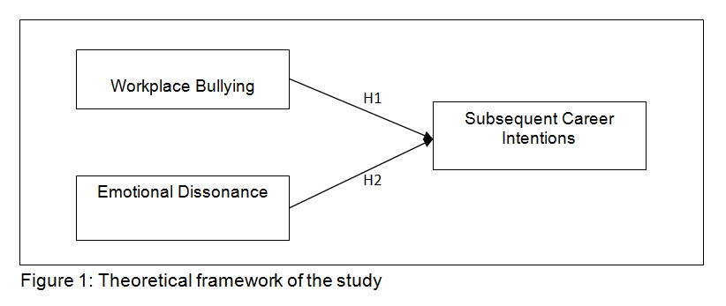
Based on the objective of this study that is to examine the influence of student trainees’ bullying experiences and emotional dissonance on their subsequent career intentions, the above theoretical framework was developed (Figure 1). The instrument used was adopted from Rayner & Hoel (1997), Chu & Murrmann (2006) and Zahari (2004) earlier related studies.

6. Methodology
6.1 Sample and data collection method
Diploma students majoring in culinary arts and hotel management from two universities in Malaysia was the focus of this study based on their prior practicum training experiences in various hotels in Malaysia. A structured group-administered questionnaire using 7-point Likert scale was used in assessing the students’ self-reported experiences and feedbacks. The students were gathered and asked to respond to the questionnaire in a group administered setting in the faculty conference halls.

6.2 Instrumentation
The following Table 1 indicates the measures of the study variables used in the study. The instrument items were adopted from previous studies by Rayner, & Hoel, (1997), Dormann & Zapf (2004), Chu & Murrmann (2006), Maslach & Jackson (1986) and Zahari (2004).
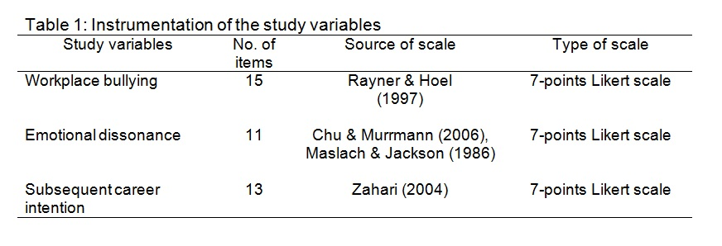
7. Finding & Discussion
7.1 Reliability analysis
The Cronbach’s alpha coefficient value for all variables in the study revealed a range of coefficient value from .78 to .82 accordingly. The dependent variable of subsequent career intentions scale had a high reliability coefficient of .82 as compared to the independent variables. The independent variables of workplace bullying and emotional dissonance had coefficient values of .78 and .79 respectively.

7.2 Descriptive statistics & analysis
The findings showed that the distribution of gender was higher for females with a total of 157 female respondents (67.7%). On the other hand, there were 75 male respondents or 32.3 percent out of the total respondents. The age of the respondents showed that most of them were 21 years old, 13.4% were 20 years old and the rest (15.1%) were above 21 years old.

8. Conclusion and Future Recommendation
Although the findings showed significant influences of workplace bullying on student trainees’ subsequent career intentions and emotional dissonance experiences did not, more detail investigation is recommended to seek and better clarify other variables similar to this study. The findings provide human resource or training managers with information on how to deal with and eliminating bullying behavior or even tendencies to do so.

Acknowledgement
This paper is under scholarship of the university.

References
Abraham, R. (1999). Emotional dissonance in organizations: conceptualizing the roles of self-esteem and job-induced tension, Leadership & Organization Development Journal, 20(1), 18-25.

Bloisi, W., & Hoel, H. (2008). Abusive work practices and bullying among chefs: A review of the literature. International Journal of Hospitality Management, 27, 649-656.

Bubany, S. T., Krieshok, T. S., Black, M. D., & McKay, R. A. (2008). College students’ perspectives on their career decision making. Journal of Career Assessment, 16(2), 177-197.

Abraham, R. (1999). Emotional dissonance in organizations: conceptualizing the roles of self-esteem and job-induced tension, Leadership & Organization Development Journal, 20(1), 18-25.

Bloisi, W., & Hoel, H. (2008). Abusive work practices and bullying among chefs: A review of the literature. International Journal of Hospitality Management, 27, 649-656.

Bubany, S. T., Krieshok, T. S., Black, M. D., & McKay, R. A. (2008). College students’ perspectives on their career decision making. Journal of Career Assessment, 16(2), 177-197.

* APA 7th Edition style for references.
* Exceed no further than 15 pages.

