A TITLE CONTAINS WORDS NEEDED TO ADEQUATELY DESCRIBE THE CONTENT OF YOUR RESEARCH

Author A^{1*}, Author B², Author C³

¹ Faculty Name, University Name, City, Country
² Faculty Name, University Name, City, Country
³ Faculty Name, University Name, City, Country

*Corresponding Author: author@university.edu
________________________________________________________________________________________

Abstract: An abstract summarizes, usually in one paragraph of 300 words or less, the major aspects of the entire paper in a prescribed sequence that includes the overall purpose of the study and the research problem, the basic design of the study, major findings as a result of your analysis; and, a brief summary of your interpretations and conclusions.

Keywords: keyword, keyword, keyword
___________________________________________________________________________
1. Introduction

Start with a couple of sentences that introduce your topic to your reader. You do not have to give too much detailed information; save that for the body of your paper.

Without an introduction it is sometimes very difficult for your audience to figure out what you are trying to say (Harrington, 2005).

2. Literature Review

What is Literature Review?
A literature review is a search and evaluation of the available literature in your given topic area. It documents the state of the art with respect to the topic you are writing about.

Table 1: Example (TNR, 10, single spacing, bold, centre)
Example | Example | Example
Example | Example | Example
Example | Example | Example

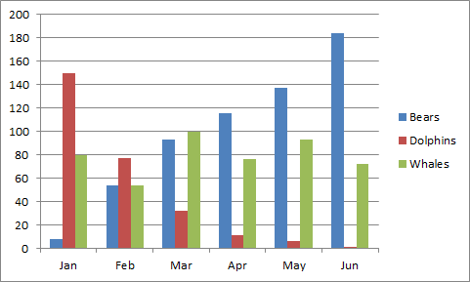
Figure 1: Example (TNR, 10, single spacing, bold, centre)
References (APA 6th Edition Format)

Harrington, A. (2005). Modern Social Theory. 1-13.
Harris, A. L., Lang, M., Yates, D., & Kruck, S. E. (2008). Incorporating Ethics and Social Responsibility in IS Education. Journal of Information Systems Education, 22(3), 183-189.
Harun, R., Hock, L. K., & Othman, F. (2011). Environmental Knowledge and Attitude among Students in Sabah. World Applied Sciences Journal, 14, 83-87.

