A TITLE CONTAINS WORDS NEEDED TO ADEQUATELY DESCRIBE THE CONTENT OF YOUR RESEARCH

Author A^{1*}, Author B² and Author C³

¹ Faculty Name, University Name, City, COUNTRY

² ³ Faculty Name, University Name, City, COUNTRY

*Corresponding author: author@university.edu

Abstract: An abstract summarizes, usually in one paragraph of 300 words or less, the major aspects of the entire paper in a prescribed sequence that includes the overall purpose of the study and the research problem, the basic design of the study, major findings as a result of your analysis; and, a brief summary of your interpretations and conclusions. Abstract should not contain citations or any statistical analysis numerical values.

Keywords: keyword1, keyword2, keyword3 etc

1. Introduction
Start with a couple of sentences that introduce your topic to your reader. You do not have to give too much detailed information; save that for the body of your paper.

Without an introduction it is sometimes very difficult for your audience to figure out what you are trying to say (Harrington, 2005).

Follow APA 6th Edition Format for citation.

2. Literature Review
A literature review is a search and evaluation of the available literature in your given topic area. It documents the state of the art with respect to the topic you are writing about.

Table 1: Example (TNR, 10, single spacing, bold, centre)
Example | Example | Example
Example | Example | Example
Example | Example | Example
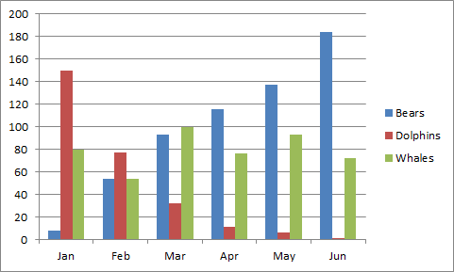
Figure 1: Example (TNR, 10, single spacing, bold, centre)

2.1 Problem Statement
State precisely the problem or gaps that this research is trying to cover.

3. Method
The method section describes actions to be taken to investigate a research problem and the rationale for the application of specific procedures or techniques used to identify, select, process, and analyze information.

3.1 Materials
Description of materials used, including site and sample and explanation of how materials were prepared.

3.1.1 Samples
Describe how the data was collected or generated and, how was it analysed. Clearly state whether there is a population that you would ideally want to generalize to; explain the characteristics of that population.

3.1.2 Site
Describe the site(s) of data collection, why the site is chosen.

3.1.3 Procedures
Describe the procedures taken to perform data collection.

Design: Make clear what type of study you have done–was your study evaluating a priori hypotheses, or was it exploratory in order to generate hypotheses? Was it a meta-analysis? Explain your design, and state whether your comparisons were within subjects, between subjects, or both.

Variables: Define the variables in the study. Make explicit the link between the theoretical constructs and the way(s) they have been operationalized in your study. Define the role of each variable in your study (e.g., dependent, independent, moderating, control). Explain how you measured or otherwise observed the variables.

Power and sample size: Provide information on the sample size and the process that led to the decision to use that size.

3.2 Measurement
Explanation of how measurements were made and calculations performed.

3.3 Data Analysis
Explanation of statistical methods utilized to analyze the data.

3.3.1 Validity and Reliability
This leads to comprehensive understanding of the problem, thereby, allowing critical evaluation on the study’s overall validity and reliability. The writing should be direct and precise and always written in the past tense.

For qualitative research type, you may have the followings sub-sections:
1. General research questions.
2. Collection of information; selection of relevant case(s), deﬁnition of the kind of instruments and collecting information.
3. Transformation of data.
4. Interpretation of data.

4. Results and Discussion
Data analysis is the most crucial part of the research. Data analysis summarizes collected data. It involves the interpretation of data gathered through the use of analytical and logical reasoning to determine patterns, relationships or trends. Discussion provides the explanation and interpretation of results or findings by comparing with the findings in prior studies.

5. Conclusion
Write the output of the work or investigations in summarized form.

6. Acknowledgement
Write your concise appreciation to all those people (or organizations) that have supported the research program.

References (APA 6th Edition Format)
Harrington, A. (2005). Modern Social Theory. 1-13.
Harris, A. L., Lang, M., Yates, D., & Kruck, S. E. (2008). Incorporating Ethics and Social Responsibility in IS Education. Journal of Information Systems Education, 22(3), 183-189.
Harun, R., Hock, L. K., & Othman, F. (2011). Environmental Knowledge and Attitude among Students in Sabah. World Applied Sciences Journal, 14, 83-87.

(Have minimum 15 references, preferably with articles 5 years or less)

