A TITLE CONTAINS WORDS NEEDED TO ADEQUATELY DESCRIBE THE CONTENT OF YOUR RESEARCH

Author A^{1*}, Author B², Author C³

¹ Faculty Name, University Name, City, Country
² Faculty Name, University Name, City, Country
³ Faculty Name, University Name, City, Country

*Corresponding Author: author@university.edu
________________________________________________________________________________________

Abstract: An abstract summarizes, usually in one paragraph of 300 words or less, the major aspects of the entire paper in a prescribed sequence that includes the overall purpose of the study and the research problem, the basic design of the study, major findings as a result of your analysis; and, a brief summary of your interpretations and conclusions.

Keywords: keyword, keyword, keyword
___________________________________________________________________________
1. Introduction
Start with a couple of sentences that introduce your topic to your reader. You do not have to give too much detailed information; save that for the body of your paper.

Without an introduction it is sometimes very difficult for your audience to figure out what you are trying to say (Harrington, 2005).

Follow APA 6th Edition Format for citation.

2. Literature Review
What is Literature Review?
A literature review is a search and evaluation of the available literature in your given topic area. It documents the state of the art with respect to the topic you are writing about.

Table 1: Example (TNR, 10, single spacing, bold, centre)
Example | Example | Example
Example | Example | Example
Example | Example | Example

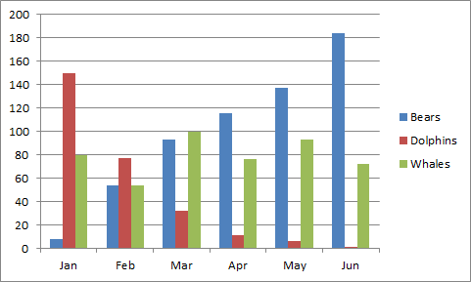
Figure 1: Example (TNR, 10, single spacing, bold, centre)

3. Problem Statement
State precisely the problem or gaps that this research is trying to cover.

4. Method
The method section describes actions to be taken to investigate a research problem and the rationale for the application of specific procedures or techniques used to identify, select, process, and analyze information.

4.1 Data Collection
The methodology section of a research paper answers two main questions: How was the data collected or generated? And, how was it analyzed?

4.1.1 Validity and Reliability

This leads to comprehensive understanding of the problem, thereby, allowing critical evaluation on the study’s overall validity and reliability. The writing should be direct and precise and always written in the past tense.

5. Results and Discussion

Data analysis is the most crucial part of the research. Data analysis summarizes collected data. It involves the interpretation of data gathered through the use of analytical and logical reasoning to determine patterns, relationships or trends. Discussion provides the explanation and interpretation of results or findings by comparing with the findings in prior studies.

6. Conclusion

Conclusion is to write the output of the work or investigations in summarized form.

7. Acknowledgement

Write your concise appreciation to all those people (or organizations) that have supported the research program.

References (APA 6th Edition Format)

Harrington, A. (2005). Modern Social Theory. 1-13.
Harris, A. L., Lang, M., Yates, D., & Kruck, S. E. (2008). Incorporating Ethics and Social Responsibility in IS Education. Journal of Information Systems Education, 22(3), 183-189.
Harun, R., Hock, L. K., & Othman, F. (2011). Environmental Knowledge and Attitude among Students in Sabah. World Applied Sciences Journal, 14, 83-87.

