Full Paper Template and Author Guidelines for Submission of Article

Author Name^{1*}, Author Name¹, Author Name²

¹ Faculty Name, University Name A, City, Country
² Faculty Name, University Name B, City, Country

*Corresponding Author: author@university.edu
__________________________________________________________________________________________

Abstract: The purpose of this document is to provide a consistent format for full papers appearing in the conference proceedings and journal. The publisher strongly encourages the authors to use the full paper template when preparing the article. This document also provides guidelines to the authors for submission of full paper for publication.

Keywords: full paper, template, author, guidelines
___________________________________________________________________________
1. Introduction

Authors should prepare their research paper according to the template and guidelines provided in this document. Paper that is not prepared according to these guidelines may be returned for revision prior to any editorial consideration.

These template and guidelines apply for both conference proceedings and journal article.

2. Full Paper Template

The uniform outlook will help the reader to follow the article easily. This can be obtained effectively if author uses this template file to construct his or her paper.

Table 1: Format of Papers
Item | Format
Paper Length | Between 5 to 15 pages. There is no limitation on the number of words.
Paper Title | Not exceeding 15 words
Abstract | Not exceeding 300 words in a single paragraph
Keyword | 3 to 5 keywords
Font | Times New Roman, Single Spacing  - Paper Title: 16-point Bold  - Abstract: 12-point Italic  - Subtitle: 12-point Bold  - Body text: 12-point Normal  - Table / Figure header: 10-point Bold
Table | Header at the top of a Table  (See Table 1 for reference)
Figure | Header at the bottom of a Figure  (See Figure 1 for reference)
Abbreviation | Define abbreviation upon first appearance in text
Reference Style | American Psychological Association (APA)

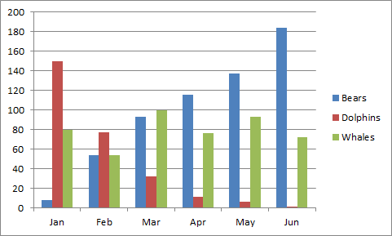
Figure 1: Example of Figure

3. Author Guidelines

Guidelines for Submission of Article
As part of the submission process, authors are required to check all of the following items, as submissions may be returned to authors that do not adhere to these guidelines.

Table 2: Submission Preparation Guidelines
Item | Description
File Format | - The submission file must be in Microsoft Word file format.  - Other formats will be rejected.
Submission Rules | - Author is responsible to ensure paper submitted has not been previously published.  - Author is responsible to ensure paper submitted must not be under consideration for publication in another journal.
Originality | - The acceptable similarity index is below 20% including references and appendices.  - Work from other publications must be appropriately cited or quoted.
Copyright and confidentiality | - Author is responsible to ensure that his or her submitted works do not infringe any existing copyright.  - Author is also responsible to protect the anonymity and confidentiality of the respondents or to obtain letters of permission from the respondents if such anonymity and confidentiality are to be compromised.

4. Conclusion

For any queries, authors may email to publication@asianscholarsnetwork.com for assistance.

References

Harrington, A. (2005). Modern Social Theory. 1-13.
Harris, A. L., Lang, M., Yates, D., & Kruck, S. E. (2008). Incorporating Ethics and Social Responsibility in IS Education. Journal of Information Systems Education, 22(3), 183-189.
Harun, R., Hock, L. K., & Othman, F. (2011). Environmental Knowledge and Attitude among Students in Sabah. World Applied Sciences Journal, 14, 83-87.

