A Title Contains Words Needed To Adequately Describe the Content of Your Research

Author Name^{1*}, Author Name¹, Author Name²

¹ Faculty Name, University Name A, City, Country
² Faculty Name, University Name B, City, Country

*Corresponding Author: author@university.edu
________________________________________________________________________________________

Abstract: An abstract summarizes, usually in one paragraph of 300 words or less, the major aspects of the entire paper in a prescribed sequence that includes the overall purpose of the study and the research problem, the basic design of the study, major findings as a result of your analysis; and, a brief summary of your interpretations and conclusions.

Keywords: keyword, keyword, keyword
_________________________________________________________________________
1. Introduction

Start with a couple of sentences that introduce your topic to your reader. You do not have to give too much detailed information; save that for the body of your paper.

Without an introduction it is sometimes very difficult for your audience to figure out what you are trying to say (Harrington, 2005).

2. Literature Review

About Literature Review
A literature review is a search and evaluation of the available literature in your given topic area. It documents the state of the art with respect to the topic you are writing about.

Tables and Figures
Tables usually show numerical value or textual information and are almost always characterized by a row-column structure. Any type of illustration other than a table is referred to as a figure. The title should be placed at the top of a table. For figure, the title should be placed at the bottom of a figure.

Table 1: Title at the top of a Table (TNR, 10, single spacing, bold, centre)
Example | Example | Example
Example | Example | Example
Example | Example | Example

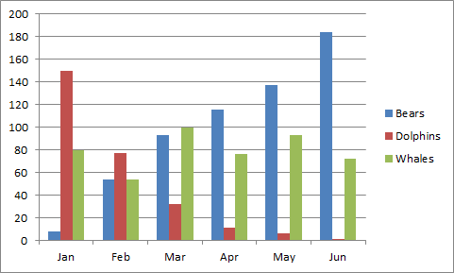
Figure 1: Title at the bottom of a Figure (TNR, 10, single spacing, bold, centre)

3. Discussion and Conclusion

The discussion and conclusions section should answer your research questions and explain what your results mean. In other words, the majority of the discussion and conclusions section should be an interpretation of your results.

References (APA 6th Edition Format)

Harrington, A. (2005). Modern Social Theory. 1-13.
Harris, A. L., Lang, M., Yates, D., & Kruck, S. E. (2008). Incorporating Ethics and Social Responsibility in IS Education. Journal of Information Systems Education, 22(3), 183-189.
Harun, R., Hock, L. K., & Othman, F. (2011). Environmental Knowledge and Attitude among Students in Sabah. World Applied Sciences Journal, 14, 83-87.

