**TAJUK** **(Palatino Linotype, font 14, bold & justify)**

*Title (Palatino Linotype, font 12, italic & justify)*

FIRST AUTHOR1, SECOND AUTHOR2, & THIRD AUTHOR3

(Palatino Linotype, font 14, uppercase & justify)

1Full address (Palatino Linotype, font 10)

2Full address (Palatino Linotype, font 10)

3Full address (Palatino Linotype, font 10)

*Corresponding author (Palatino Linotype, font 10): [email](mailto:nikfitri@usm.my) (Palatino Linotype, font 10 & justify)

Published online (Palatino Linotype, font 10):

# To cite this article (APA) (Palatino Linotype, font 10):

ABSTRACT (Palatino Linotype, font 12, uppercase) *Manuscripts should be accompanied by a single paragraph abstract of no more than 200 words. Manuscripts written in Malay must include a Malay abstract, as well as an abstract and title in English. The abstract should include the main purpose of the research, methods, results (i.e. main findings), major conclusions and implications. (Palatino Linotype, font 11, italic, single spacing & justify)*

***Keywords****: Keywords that are relevant to the content of your manuscript (normally four to five) should be listed immediately after the abstract. Please avoid, for example, keywords such as “and” or “of."* *(Palatino Linotype, font 11 & justify)*

*\*\* Papers in Malay must have an abstract and title in English with similar abstract content.*

**1. Introduction** **(Palatino Linotype, font 14, bold)**

The introduction covers (Palatino Linotype, font 12, single spacing & justify)

**2. Literature Review (Palatino Linotype, font 14, bold)**

***2.1 First theme of literature review*** **(Palatino Linotype, font 12, italic, bold)**

(Palatino Linotype, font 12, single spacing & justify)

***2.2 Second theme of literature review* (Palatino Linotype, font 12, italic, bold)**

(Palatino Linotype, font 12, single spacing & justify)

**3. Research Area (Palatino Linotype, font 14, bold)**

(Palatino Linotype, font 12, single spacing & justify)

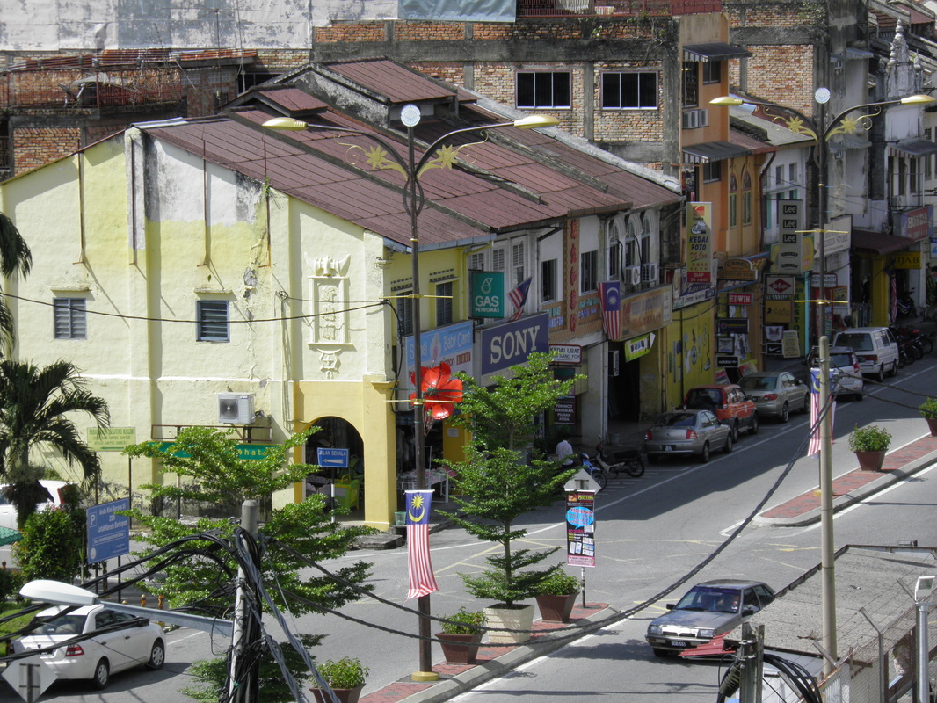

*Figure 1.*Title of figure (Palatino Linotype, font 10)

*Source:* Title of source (Palatino Linotype, font 10)

**4. Research Methodology (Palatino Linotype, font 14, bold)**

***4.1 Primary Data Collection (Palatino Linotype, font 12, bold, italic)***

(Palatino Linotype, font 12, single spacing & justify)

***4.2 Secondary Data Collection (Palatino Linotype, font 12, bold, italic)***

(Palatino Linotype, font 12, single spacing & justify)

**5. Findings and Discussion (Palatino Linotype, font 14, bold)**

***5.1 First level sub-heading (Palatino Linotype, font 12, bold, italic)***

(Palatino Linotype, font 12, single spacing & justify)

***5.2 Second level sub-heading (Palatino Linotype, font 12, bold, italic)***

(Palatino Linotype, font 12, single spacing & justify)

***5.3 Third level sub-heading (Palatino Linotype, font 12, bold, italic)***

(Palatino Linotype, font 12, single spacing & justify)

Table 1. (Palatino Linotype, font 10)

*Title of table* ***(Palatino Linotype, font 10 & italic)***

|  |  |  |
| --- | --- | --- |
| **Heading**  **(Palatino Linotype, font 10, bold)** | **Heading (Palatino Linotype, font 10, bold)** | **Heading (Palatino Linotype, font 10, bold)** |
| Content (Palatino Linotype, font 10) | Content (Palatino Linotype, font 10) | Content (Palatino Linotype, font 10) |
| Content (Palatino Linotype, font 10) | Content (Palatino Linotype, font 10) | Content (Palatino Linotype, font 10) |
| Content (Palatino Linotype, font 10) | Content (Palatino Linotype, font 10) | Content (Palatino Linotype, font 10) |
| Content (Palatino Linotype, font 10) | Content (Palatino Linotype, font 10) | Content (Palatino Linotype, font 10) |

*Source:* Source of figure (Palatino Linotype, font 10)



*Figure 2.* Title of figure (Palatino Linotype, font 10)

*Source:* (Palatino Linotype, font 10)

**6. Conclusion (Palatino Linotype, font 14, bold)**

(Palatino Linotype, font 12, single spacing & justify)

**7. REFERENCES (Palatino Linotype, font 14, Uppercase & bold)**

Palatino Linotype, font 12, single spacing & justify - APA style)

Mulley, C. (2014). Accessibility and land value uplift: Identifying spatial variations

in the accessibility impacts of a bus transitway. *Urban Studies*, 51(8), 1707- 1724.

Tonidandel, S., & LeBreton, J. M. (2011). Relative importance analysis – A useful supplement to regression analyses. *Journal of Business and Psychology*, 26, 1-9.

Department of Statistics. (2010). *The Malaysia Population and Housing Census*. Putrajaya.

Pucher, J. (2004). Public Transportation. In Hanson, S. & Giuliano, G. (eds.), *The Geography of Urban Transportation* (p. 199-236). New York, The Guilford Press.

Smith, J., Gihring, T., & Litman, T. (2009). Financing transit systems through value capture: An annotated bibliography. Victoria Transport Policy Institute. Retrieved from http://www.vtpi.org/smith.pdf (Please note that you only need to include a date of access when the page’s content is likely to change over time).

Malaitham, S. (2013). A study of urban rail transit development effects in Bangkok

Metropolitan Region (Doctoral dissertation). Retrieved from https://repository.kulib.kyotou.ac.jp/dspace/bitstream/2433/180485/2/dkogk0 3781.pdf