THE TITLE GOES HERE WITH EACH LETTER CAPITALIZED

Author's Name^{a*}
Author's Name^{b}

ª*Replace this text with corresponding author’s affiliations (use complete addresses and email address)
^{b}If more than one affiliation is needed, they should be indicated by superscript

Abstract (Capital Letter, Times New Roman 12, Bold)
Contents of abstract (Times New Roman 12, Italic, 1.15 space) Abstract must be between 150-200 words only. For those who writing in other language, need to write abstract in English too. The abstract must state the purpose, procedures and conclusions of the study. Example: Understanding customer experience and the customer journey over time is critical for firms. Customers now interact with firms through myriad touch points in multiple channels and media, and customer experiences are more social in nature. These changes require firms to integrate multiple business functions, and even external partners, in creating and delivering positive customer experiences. In this article, the authors aim to develop a stronger understanding of customer experience and the customer journey in this era of increasingly complex customer behavior. To achieve this goal, they examine existing definitions and conceptualizations of customer experience as a construct and provide a historical perspective of the roots of customer experience within marketing. Next, they attempt to bring together what is currently known about customer experience, customer journeys, and customer experience management. Finally, they identify critical areas for future research on this important topic.

Keywords: Enter Keywords here, Enter Keywords here, Enter Keywords here.

INTRODUCTION (Times New Roman 12, Bold, Title Capital Letter, please do not use numbering)
Contents of introduction (indent after second line of each paragraph, Times New Roman 12, 1.15 space, Justify) Here introduce the paper, and put a nomenclature if necessary, in a box with the same font size as the rest of the paper. The paragraphs continue from here and are only separated by headings, subheadings, images and formulae using page layout, section break.

Sub heading 1 (Times New Roman 12, Bold, Title case not capital letter, please do not use numbering)
Contents (indent Second line of each paragraph, Times New Roman 12, 1.15 space, Justify). For KEIZAC 2021, the files must be in MS Word format only and should be formatted accordingly. Please do not alter the formatting and style layouts which have been set up in this template document. As indicated in the template, papers should be prepared in single column format.
Only original papers will be accepted, and copyright of the published papers will be vested in the publisher. The submitted manuscripts must be 1.15-spaced and do not exceed 10 pages (including endnotes, references, supporting exhibits and any appendices).

Table 1. The list of
Column Header Goes Here | Column Header Goes Here | Column Header Goes Here
Row Name Here | Row Name Here This is the standard font and layout for the individual paragraphs | Row Name Here This is the standard font and layout for the individual paragraphs
Row Name Here | Row Name Here | Row Name Here
Row Name Here | Row Name Here | Row Name Here
Notes: Taken from KEIZAC 2019 Resources

Sub heading 2 (Times New Roman 12, Bold, Title case not capital letter, please do not use numbering)
Contents (indent Second line of each paragraph, Times New Roman 12, 1.15 space, Justify). On the Insert tab, the galleries include items that are designed to coordinate with the overall look of your document. You can use these galleries to insert tables, headers, footers, lists, cover pages, and other document building blocks. When you create pictures, charts, or diagrams, they also coordinate with your current document look.
You can easily change the formatting of selected text in the document text by choosing a look for the selected text from the Quick Styles gallery on the Home tab. You can also format text directly by using the other controls on the Home tab. Most controls offer a choice of using the look from the current theme or using a format that you specify directly.
To change the overall look of your document, choose new Theme elements on the Page Layout tab. To change the looks available in the Quick Style gallery, use the Change Current Quick Style Set command. Both the Themes gallery and the Quick Styles gallery provide reset commands so that you can always restore the look of your document to the original contained in your current template.

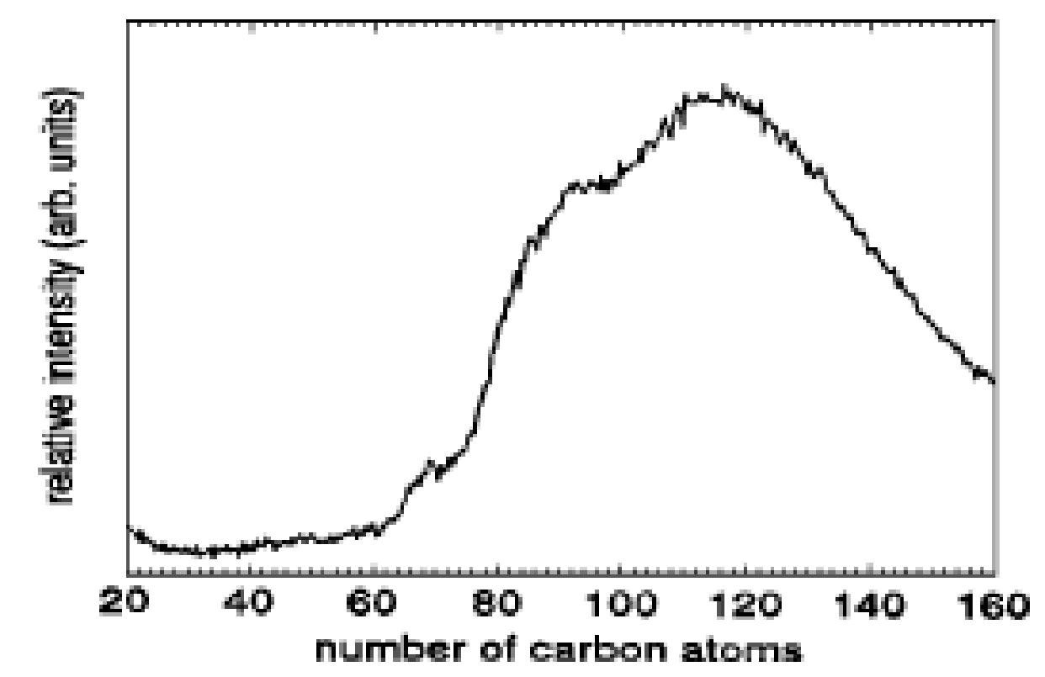
Figure 1. Title is Here

CONCLUSION (Times New Roman 12, Bold, Title capital letter, please do not use numbering)
Contents (indent Second line of each paragraph, Times New Roman 12, 1.15 space, Justify)
Below is an example equation created with Word 97’s Equation Editor. To move this equation, highlight the entire line, then use cut and paste to the new location. To use this as a template, select the entire line, then use copy and paste to place the equation in the new location.

ACKNOWLEDGMENTS
The reference section will follow the “Acknowledgment” section. This section gives credit for sponsorship for research grant or others. References should be follow APA 6th-Annotated format as indicated in the below examples.

REFERENCES
Indent second line (Times New Roman 12, 1.15 space, justify) e.g. Logan, H. (2003). The next digital divides. Title of Journal, 4(1), xx-xx.
Vol number issue number page number
Tropsha, A. (2010). Best Practices for QSAR Model Development, Validation, and Exploitation. Molecular Informatics, 29(6-7), 476-488. doi:10.1002/minf.201000061
Zainon, S., Sanusi, Z. M., Ahmad, R. A. R., Bakar, Z. A., Jaafar, M. Z., & Tahir, H. H. M. (2014). New Improved Reporting Index of Corporate Social Reporting for Shariah-compliant Companies. Procedia-Social and Behavioral Sciences, 145, 146-151.
If retrieved from the web, please include:
Retrieved on 10 January 2019, from https://www.zakatkedah.com.my/
Please use sentence case for title of paper, book etc.
Other formatting
Title of Table (Times New Roman 12, Title case not capital letter, BOLD, centre, should be above table)
Figure (Times New Roman 12, Title case not capital letter, BOLD, centre, should be below figure)
Indicator/notes to Table or Figure (Times New Roman 10)
In text citation, e.g. (Kotler, Bowen & Makens, 2010). The ‘and’ should be ‘&’. However a full spelling of and should be used in the reference list.

