Malaysia-China in the Liberalization Era: Structural Modeling of International Parity Conditions and Transmission Mechanism

Chee-Wooi, Hooy[1]ψ

School of Management,Universiti Sains Malaysia, Malaysia

[cwhooy@usm.my](mailto:cwhooy@usm.my)

Chan Tze-Haw

Graduate School of Business,Universiti Sains Malaysia, Malaysia

[thchan@usm.my](mailto:thchan@usm.my)

Tajul Ariffin Masron

School of Management,Universiti Sains Malaysia, Malaysia

[tams@usm.my](mailto:tams@usm.my)

**Abstract**

We construct a structural system that jointly examines Purchasing Power and Interest Parity conditions for Malaysia-China during 1996Q1-2010Q4. Structural VARX, over-identifying restrictions, bootstrapping and persistent profiles are …..(maximum 150 words)

**Keywords**: International Parity Conditions, Economic Integration, Transmission Mechanism, Structural Modeling, Bootstrapping (maximum 6 keywords)

**Acknowledgement:** This research was supported by a Research University (RU) grant from Universiti Sains Malaysia [Grant no: 1001/PMGT/816150]. The usual disclaimer applies

**1. Introduction**

Being a small and open economy, Malaysia is highly exposed to global economic. While foreign investment and trade have accelerated the domestic growth, the vulnerability to global price instability, financial risks and exchange rate variability is someway inevitable. It is thus crucial to scrutiny the links between the domestic and foreign economies, so that the dynamics of economic transmission mechanism can be better understood.

In the past decades, Malaysia has been closely linked to the US and Japan. ….(Frankel and Rose, 1998).[2] Motivated by the mentioned issues, we hereby construct the joint assessment of PPP and IRP between Malaysia-China using the structural modeling method…

**2. Literature Review**

Empirically, PPP requires a constant real exchange which at least exhibits reversion towards the long run mean rate over time, and not driven by stochastic trends. IRP, on the other hand, is commonly verified via the interest differential hypothesis or interest rates co-movement as indication for financial asset substitutability and capital integration across borders. While PPP is an elegant hypothesis, much failure appears in the early studies. Among others, see Hakkio (1984), Edison (1985), Frankel (1986), and Meese and Rogoff (1988), Mark (1990), Edison and Pauls (1993). These studies generally found…

**3. Methodology**

Being the first equilibrium theory of exchange rate, PPP postulates that the nominal exchange rate is proportional to the relative price so that the real exchange rate remains constant overtime. The theoretical motivation for PPP is based on the assumption that internationally produced goods are perfect substitutes for domestic goods. On the other hand, the second equilibrium theory of exchange rate―UIP, states that the interest rate differential between two countries is equal to the expected change in the spot exchange rates. UIP assumes zero risk premium so that financial assets are substitutes in cross-border capital markets.

If we let be the log spot exchange rate of RM/yuan,  and  be the log domestic (Malaysia) and foreign (China) price levels respectively, the PPP condition is defined as:

 (1)

while UIP condition is represented by

 (2)

with and  being the respective nominal interest rates denominated in domestic and foreign currencies compounded over the time period *t - (t - 1)*, and *Et* (.) denotes the expected value formed at time *t*.

**4. Results and Discussion**

Our results are reported in Table 1 and Figure 1 as follow:

Table 1: VARX Cointegrating Test, 1996Q1-2010Q4

|  |  |  |  |  |
| --- | --- | --- | --- | --- |
| *H0* | *H1* | Trace Statistic | Bootstrapped Critical Values | |
| 95% | 90% |
| *r = 0* | *r ≥ 1* | 96.8556** | 74.2452 | 70.4917 |
| *r ≤ 1* | *r ≥ 2* | 44.7480* | 46.7084 | 42.1938 |
| *lag* | *(1, 1)* | SBC = 910.8761 | Adj LR test = 190.7867[0.277] | |

Notes: ** and * denote significant at 95% and 90% confidence level respectively.

Figure 1: Persistent Profile of CV1 (PPP) and CV2 (IRP) to System-Wide Shocks

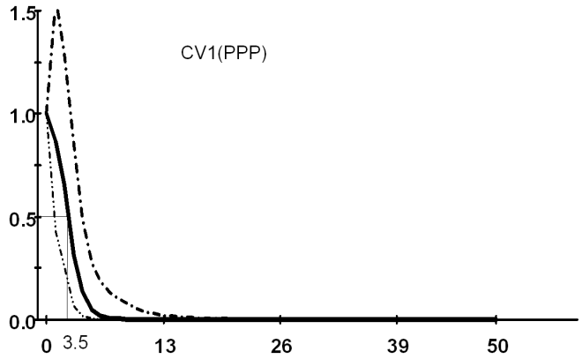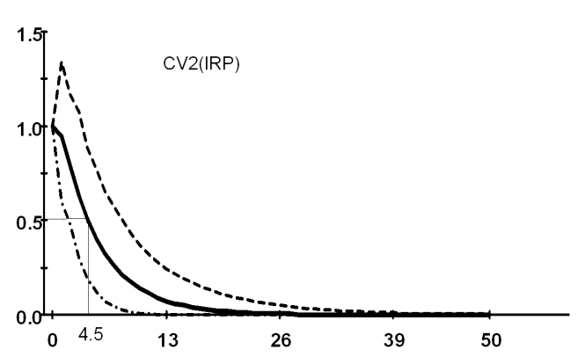

Note: The dot-lines represent the top 97.5% and low 2.5% bootstrapped confidence intervals respectively.

**5. Conclusion**

This study constructs a structural system that allow for possible interactions between the PPP and IRP so that the transmission mechanism among interest rates, prices, and exchange rates can be better understood. The empirical framework was…

**Reference**

Baharumshah, A.Z., Chan, T.-H. and Fountas, S. (2005) A panel study on real interest rate parity in East Asian countries: Pre- and post-liberalization era. *Global Finance Journal*, 16(2), 69-85.

Chan, T. H. (2008). *International Parities among China and Her Major Trading Partners in Asia Pacific*. MPRA Paper 15504, University Library of Munich, Germany.

Garratt, A., K. Lee, M. H. Pesaran and Y. Shin (2006) *Global and national macroeconometric modelling: A long run structural approach*. Oxford: Oxford University Press.

The Economist (various issues) *Big Mac index*, Retrieved from [http://www.economist.com/node/17257797](http://www.economist.com/node/17257797?story_id=17257797&CFID=163214234&CFTOKEN=64541760)

1. ψ Corresponding Author: Hooy Chee Wooi, School of Management, Universiti Sains Malaysia, 11800 USM, Penang, Malaysia; Email: [cwhooy@usm.my](mailto:cwhooy@usm.my); Tel: 604-653-3889; Fax: 604-657-7448.
2. Frankel and Rose (1998) suggest that intra-union trade is encouraged by reducing the risk of exchange rate changes and that this in turn increases the degree of synchronization between business cycles of countries comprising the union which is itself a criterion for an Optimal Currency Area (OCA).