Title of the paper (14pt Times New Roman, Centred)

AUTHOR’S NAME (Capital, 12pt Times New Roman, centred)
University (12pt Times New Roman, centred)

AUTHOR’S NAME (Capital, 12pt Times New Roman, centred)
University (12pt Times New Roman, centred)

ABSTRACT (Capital, 12pt Times New Roman, Italics)

Abstract should summarize the content of the paper in a single paragraph and maximum of 300 words. The abstract shall be written in the language used in the manuscripts (English or Bahasa Melayu) and it should consist of problem statement, objective, brief methodology, finding and conclusion. It should be in single spacing, font Times New Roman. For manuscripts written in Bahasa Melayu, authors are also required to provide English translation of the abstract and keywords.

Keywords: At least 5 keywords and separated with comma.

INTRODUCTION (Capital, 12pt Times New Roman)

This is a sample of the format of your full paper. A minimum of 10 A4-sized pages (21 x 29.7cm) pages with top and margins of 2.5cm and left and right margins of 1.8 cm. Use single space, 10 pt size Times New Roman throughout the paper except for the headlines.

In general, the contents should comprise Introduction, Literature Review, Methodology, Results and Discussion, Conclusion, Acknowledgement and References.

LITERATURE REVIEW (Capital, 12pt Times New Roman)

All illustrations including figures, charts and graphs, must be labelled and supplied on pages separate from the text.

METHODOLOGY (Capital, 12pt Times New Roman)

………………………………………………………………………………………………………………...........

SUB-SECTION (Capital, 11pt Times New Roman)

………………………………………………………………………………………………………………...........

RESULTS AND DISCUSSION (Capital, 12pt Times New Roman)

……………………………………………………………………………………………………………

REFERENCES (Capital, 12pt Times New Roman)

REFERENCE CITATIONS

- All entries in the reference list must be cited in text. Cite references in text using the author-date method [e.g., Adams (1999).
- If a work has two authors, always cite both names every time the work is referred to in the text.
- If a work has three to five authors, cite all authors the first time the reference occurs; in subsequent citations, include only the name of the first author followed by “et al.” and the year.
- For works with six or more authors, use only the name of the first author followed by “et al.” and the year whenever the work is cited (in the reference list, however all names must be given).
- Pages number should be provided when specific arguments or findings of authors are paraphrased, summarized, or directly quoted. Examples :
First citation in text
Adams and Yong (2011) argued that . . .
Lim, Ahmad and Bricks (2003) found . . .

Subsequent citations
Ali and Mariah (2011) argued that . . . Lim et al. (2003) found . . .
- For parenthetical citations of two or more works, use alphabetical ordering and ampersands (&). Separate each cited work by semicolons except for multiple works by the same authors which must be separated by comas. Example:
Several researchers (e.g., Bushee 2001; Darrough & Rangan 2004, 2010; Norman & Kamran 2005; Shen & Chih 2005; Woidtke 2002) supported this argument.

REFERENCE LIST
- A Roman alphabetically-ordered reference list should be included at the end of the manuscript. All references cited in text must appear in the reference list. Authors are responsible for the accuracy and completeness of all information in a reference.
- Several references by the same author(s) should be ordered chronologically (earliest date first). Multiple references to works by an identical author(s) with the same publication date should be arranged alphabetically by the title that follows the date (excluding A or The) and differentiated by adding lowercase letters (a, b, c, etc.) immediately after the year. For periodicals, include an issue number only if the pages of the periodical are not numbered consecutively throughout the volume (i.e., if each issue begins with page 1)
- Type each entry using a hanging-indent format of 0.73 cm.

FIGURE 1. Interrelation between Socio and Macroeconomic Variables and Crime
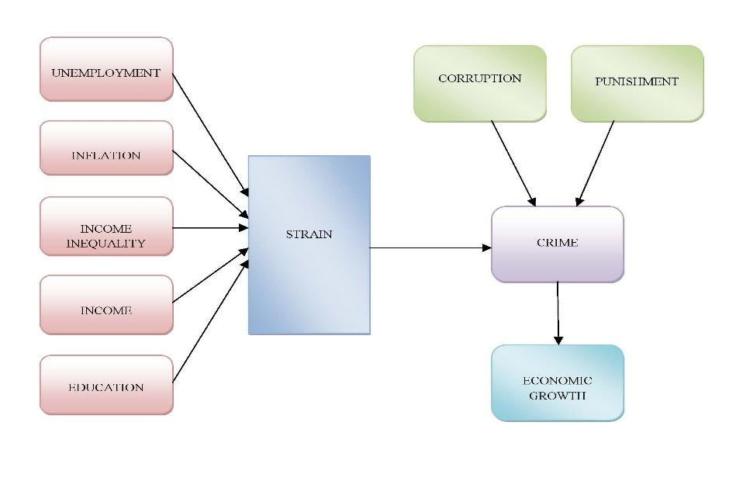
Source: State the source if the figure is copied from elsewhere

TABLE 1. Pearson Correlation matrix among variables

 |  | Encouragement | Competency | Governance
 | Readiness | 0.0123 | 0.550 | 0.610
 | Competency |  | 1.000 | 0.058
 | Governance |  |  | 1.000

Source: State the source if the table is copied from elsewhere

