TITLE (Times New Roman, size 14, bold)
(Title in English, if the manuscript is in Malay) (Times New Roman, size 14, italic)

Author A¹ & Author B²
¹ Author A’s affiliation, email (please denote corresponding author)
² Author B’s affiliation, email (please denote corresponding author)

Abstract (Times New Roman, size 12, 200-250 words)
It is suggested that the abstract section have the following items: problem statement, methodology, main findings, discussion, and implication/novelty of the study/recommendation. It is suggested that the abstract section have the following items: problem statement, methodology, main findings, discussion, and implication/novelty of the study/recommendation. It is suggested that the abstract section have the following items: problem statement, methodology, main findings, discussion, and implication/novelty of the study/recommendation. It is suggested that the abstract section have the following items: problem statement, methodology, main findings, discussion, and implication/novelty of the study/recommendation.
Keywords: 4-6 keywords

[Main text 6000-7000 words, in-text citation using APA style]
Introduction
Times New Roman, size 12

Literature Review (if relevant)
Times New Roman, size 12

Methodology (if relevant)
Times New Roman, size 12

Result (if relevant)
Times New Roman, size 12

Table 1: Relationship between Variable X and Variable Y
Variable X | Variable Y
A | 1
B | 2
C | 3
D | 4
Source: Ali (2019)

Figure 1: Ayasofya Camii (Ayasofya Mosque)
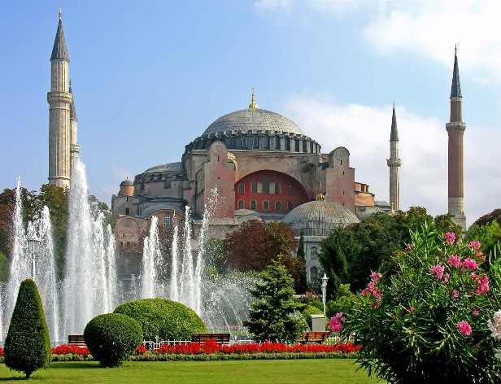
Source: Encyclopedia Britannica

Discussion
Times New Roman, size 12

Conclusion
Times New Roman, size 12

Acknowledgement (if relevant)
Times New Roman, size 12

References
APA style

