International Conference on Cross- Disciplinary Academic Research 2023(ICAR 2023)
Online/Physical Conference
Paper No. XXX (The number assigned by the ICAR Committee)

Full Paper Title in Title Case

Name Surname, Name Surname
My Institute/Company
Address, City, Country
First.Author@institution.org; Second.Author@institution.org
Name Surname
University of Ottawa, Department of Chemical Engineering
161 Louis Pasteur, Ottawa, Ontario, Canada K1N 6N5
Third.Author@uottawa.ca

ABSTRACT
In this paper, the formatting requirements for INTERNATIONAL CONFERENCE OF CROSSDISCIPLINARY ACADEMIC RESEARCH 2021 (ICAR 2021) are described. Some recommendations on writing for a worldwide readership are offered. Please review this document to learn about the formatting of text, table captions, references, and the method to include the indexing information. The conference proceedings will be published in an electronic format. The full paper in MS Word file shall be written in compliance with these instructions. At a later stage, it will be converted into Portable Document Format (PDF).
An abstract in between 200 to 300 words should appear on the top of the first page, after the title of the paper in a section titled "ABSTRACT" (without a section number), after the names of the authors.

KEYWORDS: 4 - 8 keywords

1 INTRODUCTION
It is expected that authors will submit carefully written and proofread material. Careful checking for spelling and grammatical errors should be performed. The number of pages of the paper should be from 4 to 14.
Papers should clearly describe the background of the subject, the authors work, including the methods used, results and concluding the discussion on the importance of the work. Papers are to be prepared in English. Technical terms should be explained. Acronyms should be written out at their first appearance.

2 PAPER FORMAT
The uniform appearance will assist the reader to read the paper of the proceedings. It is therefore suggested to authors to use the example of this file to construct their papers. This particular example uses an American letter format with 25 mm margins left, right, top and bottom.
All text paragraphs should be single-spaced, with the first line intended by 10 mm. Double spacing should only be used before and after headings and subheadings as shown in this example. Position and style of headings and subheadings should follow this example. No spaces should be placed between paragraphs.

2.1 Header, Footer, Page Numbering
Authors are asked to replace the "XXX" number (with the paper code that was assigned when the paper was accepted) on the header of the first page and on the footer of other pages..

2.2 Fonts
Papers should use 11-point Times New Roman font. The styles available are bold, italic and underlined. It is recommended that text in figures should not smaller than the 10-point font size.

2.3 Tables and Figures
Figure captions and table headings should be sufficient to explain the figure or table without needing to refer to the text. Figures and tables not cited in the text should not be presented. The following is an example for Table 1.
Table 1 Title of the Table
Type of nanoparticles | Average size (nm) | Variance (nm)
CuO | 47 | 4.2
NiO | 35 | 6.4
Al₂O₃ | 42 | 2.1
SnO₂ | 27 | 3.9

Tables and figures should be placed close after their first reference in the text. All figures and tables should be numbered with Arabic numerals. Table headings should be centred above the tables. Figure captions should be centred below the figures as shown in Figure 1.

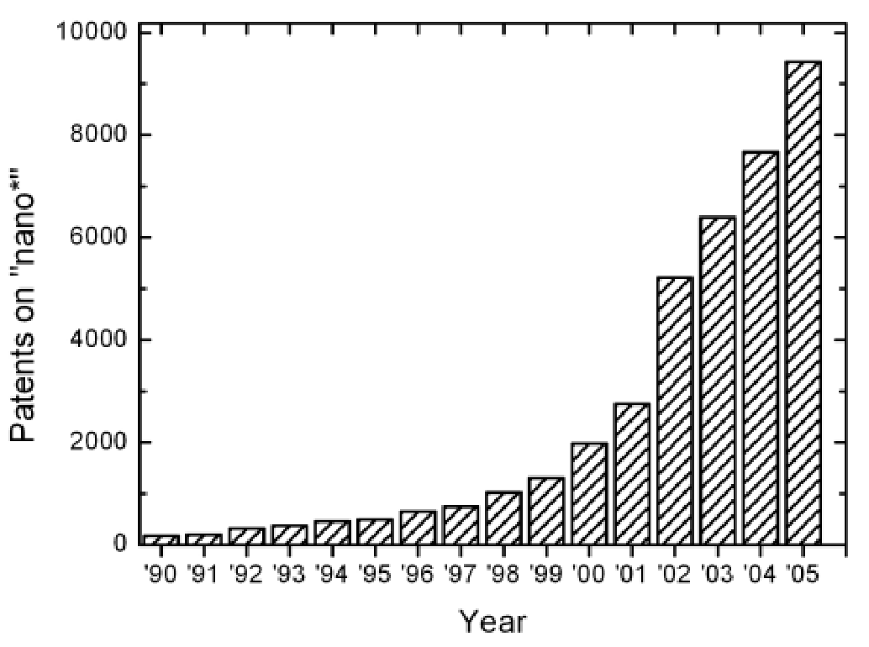
Figure 1: Number of patents on nanotechnology with time

2.4 Equations
Each equation should be presented on a separate line from the text with a blank space above and below. Equations should be clear and expressions used should be explained in the text. The equations should be numbered consecutively at the outer right margin, as shown in Eqs. (1) - (2) below. Here is one example.
In this case, the governing system of equations can be written as follows:
^{¶r}= -Ñ×(r_{u}) (1)
¶t
^{ræ}ç ¶¶t +u×Ñ^{ö}÷øu= -ÑP+rg+¹c J B´ (2) è
ræçè ¶¶t +u×Ñö÷øe = -PÑ×u+ru g× +s1J2 (3)

2.5 References
List of references must follow A.P.A style. Proper references must be included throughout the text and the list of references must be provided in this section. The references inserted in the text and the list of references must be done as follow:
Reference citations: Citations in the main body, appendices, tables and figures are to be made using the last name of the author (both authors when only two; first author plus et al. when more than two). Example: "... as previously shown (Jones et al., 1989)," or "... as shown by Jones et al. (1989)." For two or more papers published in the same year by the same author(s), add a, b, c, etc. to the year such as (1980a) or (1980b) and cite jointly as Jones et al. (1980a, b).
List of references: List all cited references (including citations in tables, figures and appendices) in alphabetical order according to the first-named author. The titles of papers, patents and books or monograph chapters and the initial and final page numbers are to be included. Abbreviations of journal names should conform to the usage of Chemical Abstracts. Example for journal papers, book/monograph sections or chapters, and conference proceedings are given the reference section at the end of this document.
Referencing websites: With the increasing availability of useful information that can be found on the internet, website references must also be reported. At the end of the reference list, make a separate section of websites and the date consulted. However, to avoid very long website addresses, these references should be referred to as Web-1, Web-2, etc. For example, in the body of the report: “… it was shown that the heat transfer coefficient of Nano fluids increased by 40% (Web-1) …”. In the reference list, provide the list of websites with the numeral values used in the text.

3 SUBMITTING THE PAPER
The full paper has to be submitted electronically via the website of the conference (https://sites.google.com/kuptm.edu.my/track-submission/submission).
Paper number (in the format "XXX") is assigned to each abstract after it was submitted through our system and authors are kindly asked to place this paper number to the correct positions in the header and footer before submitting the final version.

4 CONCLUSION
Conclusions should state concisely the most important propositions of the paper as well as the author’s views of the practical implications of the results.

5 ACKNOWLEDGEMENTS
A short acknowledgement section can be written between the conclusion and the references. Sponsorship and financial support acknowledgements should be included here. Acknowledging the contributions of other colleagues who are not included in the authorship of this paper is also added in this section. If no acknowledgement is necessary, this section should not appear in the paper.

REFERENCES
Expert A. and Expert B.C. (2008). Polymer-Clay Nanocomposites. Int. J. Nanotechnology and Applications, 58, 171–176.
Hall B. and Maisonneuve M. (2005). The Nature of Nanofiltration Membrane Porosity," in "Proc. 2nd Int. Conf. Sep. Sci. Technol.," M.H. Weir and S. Vijay, Eds., Toronto, ON, Canada, October 1–4, 2007, pp. 36–43.

