Title of Manuscript (Times New Roman 14)
AUTHOR/S (TNR10)
Affiliation/ Corresponding Author email (TNR10 italics)
ABSTRACT (TNR10)
Put your abstract here. Use single spacing and don’t exceed 250 words. Put your abstract here. Use single spacing and don’t exceed 250 words. Put your abstract here. Use single spacing and don’t exceed 250 words. Put your abstract here. Use single spacing and don’t exceed 250 words. Put your abstract here. Use single spacing and don’t exceed 250 words. Put your abstract here. Use single spacing and don’t exceed 250 words. Put your abstract here. Use single spacing and don’t exceed 250 words. Put your abstract here. Use single spacing and don’t exceed 250 words. (TNR10)
Keywords: (maximum of 5 keywords separated by semi colon) (TNR10)
HEADING LEVEL 1(TNR12)
Use Times New Roman 12 only throughout unless stated otherwise. Do not indent the first line of paragraph following a heading or sub heading. Use single spacing for main document. Note that there is only one space between sentences. Use single spacing for main document. Note that there is only one space between sentences.
Indent 5 spaces subsequent paragraphs. Indent 5 spaces subsequent paragraphs. Indent 5 spaces subsequent paragraphs. Indent 5 spaces subsequent paragraphs.
When quotations run into more than 40 words indent as shown here. Use Times New Roman 9 as font size. When quotations run into more than 40 words indent as shown here use Times New Roman 9 as font size.. When quotations run into more than 40 words indent as shown here use Times New Roman 9 as font size.
Do not use numbers or alphabets in headings and sub-headings (Example A. Introduction 1. Body). Use the following style for headings and sub-headings
USE THIS STYLE FOR LEVEL TWO HEADINGS (TNR10)
USE THIS STYLE FOR LEVEL THREE HEADINGS (TNR8)
Use a First paragraph to create a level four heading. Run text on after a full stop.

1
Including tables and figures in manuscript
[Use Times New Roman font size 7 for - TABLE 1, FIGURE 1. Use Times New Roman font size 9 for labels - Simple example of a table]
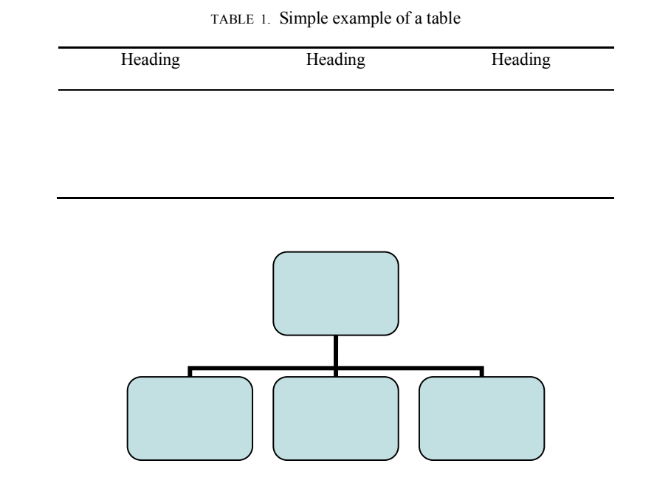
TABLE 1. Simple example of a table
Heading Heading Heading
FIGURE 1. This is an example of a figure
ACKNOWLEDGEMENTS (TNR10)

FIGURE 1 : This is an example of a figure

Place any acknowledgement here. For example, This work was supported by the Research Fund provided by xxxxxxxxxx.
Avoid identifying any of the authors prior to the review. Replace instances where name of authors appear with ‘author’

2

