A Title Contains Words Needed To Adequately Describe the Content of Your Research

Author A^{1*}, Author B², Author C³

¹ Faculty Name, University Name, City, Country
² Faculty Name, University Name, City, Country
³ Faculty Name, University Name, City, Country

*Corresponding Author: author@university.edu

Accepted: 1 March 2020 | Published: 1 April 2020
_________________________________________________________________________________________

Abstract: An abstract summarizes, usually in one paragraph of 300 words or less, the major aspects of the entire paper in a prescribed sequence that includes the overall purpose of the study and the research problem, the basic design of the study, major findings as a result of your analysis; and, a brief summary of your interpretations and conclusions.

Keywords: keyword, keyword, keyword
_________________________________________________________________________

1. Introduction

Start with a couple of sentences that introduce your topic to your reader. You do not have to give too much detailed information; save that for the body of your paper.

Without an introduction it is sometimes very difficult for your audience to figure out what you are trying to say (Harrington, 2005).

2. Literature Review

What is Literature Review?
A literature review is a search and evaluation of the available literature in your given topic area. It documents the state of the art with respect to the topic you are writing about.

Table 1: Example (TNR, 10, single spacing, bold, centre)
Example | Example | Example
Example | Example | Example
Example | Example | Example

Importance of Literature Review in Research
The literature review is important because it describes how the proposed research is related to prior research in statistics. It shows the originality and relevance of your research problem. You should spend a lot of time on your literature review because if you do it well, you can use most of it in your dissertation.

There are many different types of literature reviews, each with its own approach, analysis, and purpose. Through rigorous review and analysis of literature that meets specific criteria, the systematic review identifies and compares answers to health care related questions.

3. Methodology

Choosing Appropriate Research Methodologies
Research methodology is a process used to collect information and data for the purpose of making business decisions. The methodology may include publication research, interviews, surveys and other research techniques, and could include both present and historical information.

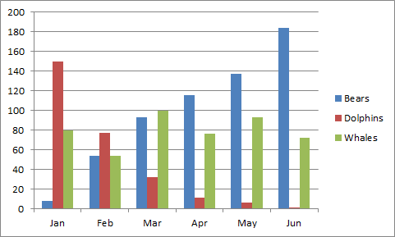
Figure 1: Example (TNR, 10, single spacing, bold, centre)

4. Conclusion

The conclusion allows you to have the final say on the issues you have raised in your paper, to synthesize your thoughts, to demonstrate the importance of your ideas, and to propel your reader to a new view of the subject. It is also your opportunity to make a good final impression and to end on a positive note.
References (APA Format)

Harrington, A. (2005). Modern Social Theory. 1-13.
Harris, A. L., Lang, M., Yates, D., & Kruck, S. E. (2008). Incorporating Ethics and Social Responsibility in IS Education. Journal of Information Systems Education, 22(3), 183-189.
Harun, R., Hock, L. K., & Othman, F. (2011). Environmental Knowledge and Attitude among Students in Sabah. World Applied Sciences Journal, 14, 83-87.

