[Manuscripts should be typed (with a wide margin and double spaced, Times New Roman (font size 12), please insert line number - continuous]

TITLE OF PAPER
[Title: uppercase, Times New Roman (font size 12), centered, single spacing paragraph]

Abstract: This template gives formatting guidelines for authors preparing papers for publication in the Journal of Sustainability Science and Management. The authors must follow the instructions given in the document for the papers to be published. You can use this document as both an instruction set and as a template into which you can type your own text.

[Abstract words in English. Use Times New Roman (font size 12) with text justified. Leave two blank lines before text of paper]

Keywords: [maximum 6, Times New Roman (font size 12) and text position left. Leave one blank line after abstract]

Introduction
[All first order heading use Times New Roman (font size 12), bold and left alignment]
This template gives formatting guidelines for authors preparing papers for publication in the Journal of Sustainability Science and Management. The authors must follow the instructions given in the document for the papers to be published. You can use this document as both an instruction set and as a template into which you can type your own text.

If reference is made in the text to a publication written by less than two authors the name of all authors should be used (Hall & Fitzgerald, 2006).

If reference is made in the text to a publication written by more than two authors the name of the first author should be used followed by “et al.,” (Hall et al., 2008).

For more than two references by the same author, list the citations in chronological sequence with the earliest first, (Azmi, 2015; 2017).

For two or more articles by the same author within the same year: (Azmi, 2015a; 2015b) When two or more articles by different authors are cited at the same time, list the citations in chronological sequence with the earliest first: (Azmi, 2015; Afzan 2016; Wahi 2017).

[The text should be justified, Times New Roman (font size 12) and unindented. Symbols should be specified and spelled out for the first time, thereafter the symbol used. SI-units should be used wherever possible. If other units and non-standard abbreviations cannot be avoided, they should be defined at first mention]

Materials and Methods

Subheading

[Heading and subheading should not be run within the text. They should be typed on a separate line without indentation. Use bold face, capitalize each word letter type and use italics letter type for subheadings]

Results and Discussion

This template gives formatting guidelines for authors preparing papers for publication in the Journal of Sustainability Science and Management. The authors must follow the instructions given in the document for the papers to be published. You can use this document as both an instruction set and as a template into which you can type your own text.

Table 1: [Table text and caption should centered, Times New Roman (font 12),
included in body text] Every table should be labeled with a reference number (Arabic numerals). Tables should be drawn using clear horizontal lines. No vertical or diagonal lines.

Title 2 | Title 3 | Title 4 | Title 5 | Title 6
Text A
Text B
Text C

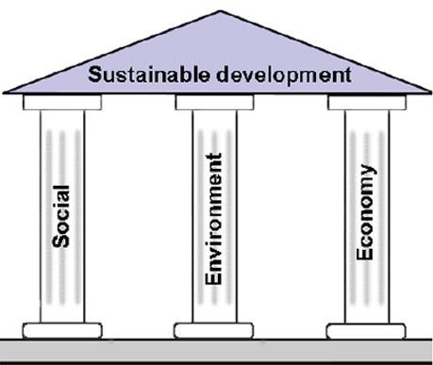

Figure 1: [Illustration text and caption should centered, font size 12, included in body text] Every figure must be clear, of high quality and given Arabic numerals.

Conclusion

This template gives formatting guidelines for authors preparing papers for publication in the Journal of Sustainability Science and Management. The authors must follow the instructions given in the document for the papers to be published. You can use this document as both an instruction set and as a template into which you can type your own text.

Acknowledgements

This template gives formatting guidelines for authors preparing papers for publication in the Journal of Sustainability Science and Management. The authors must follow the instructions given in the document for the papers to be published. You can use this document as both an instruction set and as a template into which you can type your own text.
[This should be included whenever appropriate as a separate section before Reference section, Times New Roman (font size 12)]

References

[Listed in numerical order in the References, Times New Roman, font size 12, justified with APA 6th edition format system]:

Articles in Journal
Author, A. (year). Title of paper. Journal title, volume (issue number), pages
Author, A., & Author, B. (year). Title of paper. Journal title, volume (issue number), pages

Author, A., Author, B., & Author, C. (year). Title of paper. Journal title, volume (issue number), pages

Dame, R., & Libes, S. (1993). Oyster reefs and nutrient retention tidal creeks. Journal of Experimental Marine Biology and Ecology, 171: 251-258.

Book
Authors, years, book title. publisher name, country. volume, issue number: and pages

Zar, J. H. (1999). Biostatistical analysis, 4th edition. Prentice-Hall, Englewood Cliffs, New Jersey. 718 pp.

Multi-author books

Authors, years, book title. publisher name, country. volume, issue number: and pages

Kernis, M. H., Cornell, D. P., Sun, C. R., Berry, A., Harlow, T., & Bach, J. S. (1993). There’s more to self-esteem than whether it is high or low: The importance of stability of self- esteem. Journal of Personality and Social Psychology, 65: 1190-1204

Thesis
Author, years, thesis title, degree, and university

Khalik, W. M. A. W. M. (2012). Status kualiti air Tasik Temenggor, Perak. Thesis of Master Degree, Universiti Kebangsaan Malaysia.

Webpage
Author or institution, year, title, link website, date access

Kenneth, I. A. (2001). How to be an entrepreneur. Retrieved from http://www.business.com/money/how.html, 20 August 2016.

