Note:
- The Full paper must be written in ENGLISH only.
- The Full Paper should contain a maximum of 8 – 10 pages only.
TITLE OF PAPER (Arial, 14 Font Size, Bold, Capital Letters)

^{1*}Author’s Name & ²Co-Author’s Name/s – if any (Arial, 12 Font Size, * indicate corresponding Author)

^{1&2}University / Institute, Country (Arial, 11 Font Size, Italic)

*Corresponding email: (Arial, 11 Font Size, Italic)

ABSTRACT (Arial, 11 Font Size, 250 – 300 words)
An abstract is a single paragraph, without indentation, compendious summary of a paper's substance including research question, background, purpose, methodology, results, and conclusion in 250 to 300 words.

Keywords: (Arial, 11 Font Size, Maximum 6 words)

INTRODUCTION (Arial, 14 Font Size, Bold, Capital Letters)
(Arial, 11 Font Size, Justify) Research aims and objectives, including hypothesis if any. Rationale for the study, i.e., why the issues for investigation were important or significant. Might define technical or specialist terms. Outlines scope of the report. Briefly states how report is organised.

Title of the 2nd Level (Arial, 12 font size, bold, Capitalized Each Word)
(Arial, 11 Font Size, Justify) Text, text, text, text, text, text, text, text, text, text, text, text, text, text, text, text, text, text, text, text, text, text, text, text, text, text, text, text, text, text, text, text, text, text, text, text, text, text, text, text, text, text, text, text, text, text, text, text, text, text.

Tables and figures should be numbered and references to them must be in the text. Acceptable labelling for a table is Tab.1 and Fig. 1 for a figure.

Table 1: Table description (Arial, 10 font size, Italics)
Arial10pt | Arial10pt | Arial10pt
Arial10pt | Arial10pt | Arial10pt
Arial10pt | Arial10pt | Arial10pt
Arial10pt | Arial10pt | Arial10pt

Source: (Arial, 10 font size, Italics)

LITERATURE REVIEW (Arial, 14 Font Size, Bold, Capital Letters)
(Arial, 11 Font Size, Justify) Survey of key literature: summary of major themes, concepts and/or trends. Situates current research in relation to existing literature; e.g., how it will add to current knowledge, or address existing gap.

METHODOLOGY (Arial, 14 Font Size, Bold, Capital Letters)
(Arial, 11 Font Size, Justify) Gives precise details of methods and procedures, e.g.,
- Study’s participants, and how they were chosen;
- Data collection methods (e.g. surveys, interviews, questionnaires, personal observation, case study);
- Process of ethical consent if applicable.
- Data analysis methods

RESULTS AND FINDING (Arial, 14 Font Size, Bold, Capital Letters)
(Arial, 11 Font Size, Justify) Presents results objectively, without discussion. Can include explanatory or supporting data (e.g., extracts from interviews). Include illustrations, figures or tables.
Figure 1: Figure description (Arial, 10 font size, centered, italics)
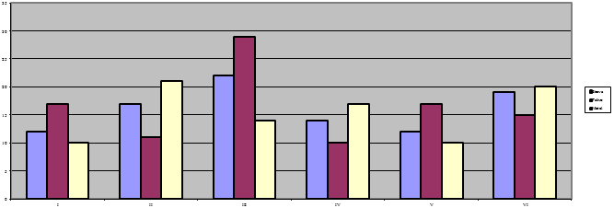
Source: (Arial, 10 font size, Italics)

DISCUSSIONS, RECOMMENDATIONS AND CONCLUSIONS (Arial, 14 Font Size, Bold, Capital Letters)
(Arial, 11 Font Size, Justify) Discussion of results. Comments on significant findings, and implications. May also include:
- Whether any initial hypothesis was supported;
- Whether or not the findings met the aims of the study;
- A comparison of your findings with other research;
- Limitations, flaws or problems in study design or methods.

Conclusions

Clearly and concise conclusion for study. Briefly re-states how well the study design met the study's aims. Emphasizes major findings and implications of findings as addressed in discussion section. Briefly re-caps any faults or limitations covered in full in the discussion section. If applicable, suggests future research directions.

Recommendations (if applicable)

Summarizes and lists in order of importance. May also be numbered.

REFERENCE (Arial, 14 Font Size, Bold, Capital Letters)

Alphabetical list of references. Start on new page, attach to end of report, before appendices. For each work shown in the list of references must be a reference in the text. All citations in the text and all references must meet APA styles (American Psychological Association 7th edition format)

