EXTENDED ABSTRACT TITLE
(Bold, All Caps, Times 14, centered paragraph)

Full Name¹*, Full Name² & Full Name³ (Times 11)
^{1,2}Faculty of Law, Universiti Teknologi MARA, Malaysia. (Times 10, Italic)
³Faculty/Institute of xxx, Universiti xxx, Country.

Email: ¹xxx@uitm.edu.my; ²yyy@uitm.edu.my; ³aaa@bbb.ccc

*Corresponding author (Times 10, Italic)

ABSTRACT (Bold, All Caps, Times 11)
Use Times with 11 point for abstract writing. You may type out or paste your text into this file, but remember to keep the page margin the same as set here which is 2.5 cm all round. Paragraph is justified on both left and right. Use single-line spacing. The limit for your abstract is between 175 to 250 words.. The abstract must be a brief, comprehensive summary of the contents of the article. It should succinctly summarize the purpose of the paper, the methods used, the major results, and conclusions. Abstracts that do not meet these formatting requirements will be returned. The organizing committee reserves the right to edit abstracts for clarity or correctness of English/Bahasa, but will consult the author if any significant changes are needed.

Keywords: Please provide not more than 5 keywords. The keywords should be typed using Times, Font size 11, Italic, Single Paragraph
Example: Food Safety, Consumers, Labelling, Sustainable, Reform

Themes: (Related Theme)

INTRODUCTION (Bold, All Caps, Times 11)
This format is to be used for submission of extended abstract which will be published as e-proceeding with e-ISBN. Extended abstract is a brief and shorter version of the full paper. Extended abstract should be written in MS Word format, single-spaced, Times New Roman 11. Extended abstract can contain figures, tables, formulations or images. Extended abstract must include abstract and keywords, introduction, literature review, methodology, findings and discussion, conclusion and recommendations. Extended abstract should be between 1.5 to 3 pages, including the references. Pages should not be numbered.
In the Introduction section, the author should address the following information; background of the research/study, problem statement, the aim, research objectives and research questions.
LITERATURE REVIEW
Key relevant literature must be reviewed to identify any gaps and place where the current study fits in relation to prior research.

METHODOLOGY
This section contains explanation on methodological approach adopted in the research, methods of data collection and methods of data analysis.

FINDINGS AND DISCUSSION
The author may insert figures, tables or images in the extended abstract. They should be numbered consecutively and inserted within the text. The captions for figure should be placed below the illustrations, whereas the captions for table should be placed above the table content. Captions should be typed out in Times, font size 10. Provide the source of the date/visual image if you did not create it yourself. If copying and pasting an image, make sure all elements are clear and readable.

Example of figure and its caption is shown in Figure 1.

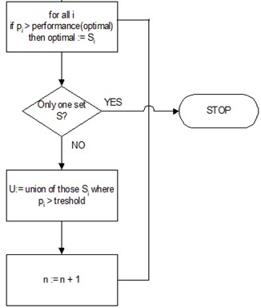
Figure 1: A flow chart of the feature selection heuristic. (Times 10)

Example of table and its caption is shown in Table 1.

Table 1: Floating-point operations necessary to classify a sample

Model | Feature extraction | Pre-processing | Classification
KKNN | >200,000 flops | ~10 flops | ~200 flops
ff NN |  |  | ~10,000 flops
Source: xxxxxx

CONCLUSION AND RECOMMENDATIONS
Please conclude your work incorporating your most important finding, recommendations as well as future works.

ACKNOWLEDGEMENT
Please acknowledge your research grant, organization, scholarship (where relevant)

REFERENCES
Use APA 7th edition for citation purpose. You may refer to Victoria University, Melbourne website for guideline at https://libraryguides.vu.edu.au/apa-referencing/7FormatsAndExamples

Limit the number of references between 10-15 only.

