INFORMATION FOR 2016 POSTER COMPETITION

Contest Terms:
The poster must be 33.1” x 46.8” (AO size) in size and contains:
- Institute/Agency Logo
- Name and address / e-mail of the participant.
The Poster Should Include:
- Research Title
- Researcher’s Name
- Research Background
- Research Objective(s)/ Methodology/ Sample l
- Research Findings/Output (Publications/Policy Implications/etc.)
- Related Photos
- QR Code (as instruction given)
- Others (if related)
- Contact Address
- E-mail / Telephone No.
Instruction for QR Code:
Step 1:  Upload your presentation video on YouTube from your own account or agencies. | 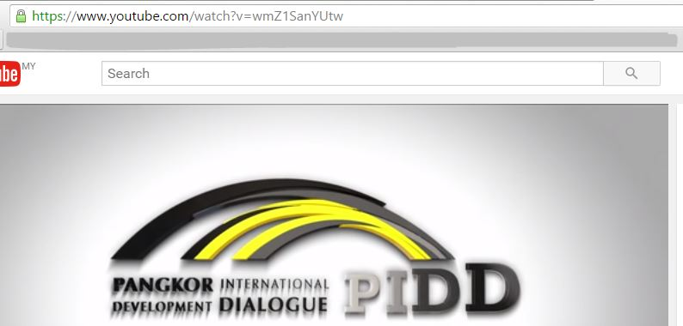
Step 2:  Open QRCODE MONKEY website.  Insert your url video presentation into http://www.qrcode-monkey.com/ | 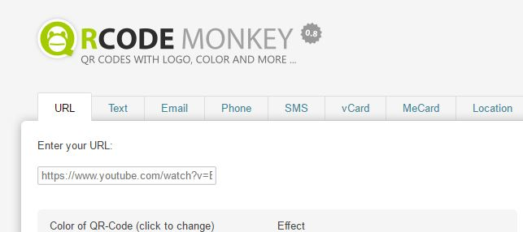
Step 3:  Generate your QR Code. | 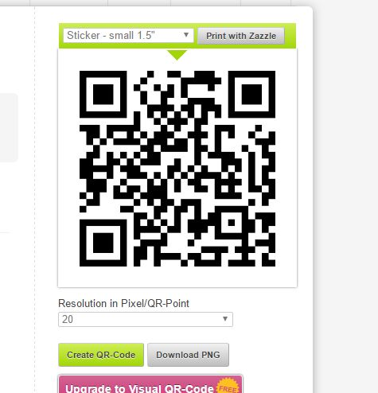
Step 4:

Download and copy your QR Code and insert at your poster.
Step 5:

Finished.

Example:

