Title of the paper (14pt Times New Roman, Centred)
Leave one blank
e blank
Margins 1.8 cm
Margins 1.8 cm
Margins 2.5 cm

Author’s Name (12pt Times New Roman, bold, centred)
University (12pt Times New Roman, centred)
Leave one blank

Author’s Name (12pt Times New Roman, bold, centred)
University (12pt Times New Roman, centred)
Leave two blanks

ABSTRACT (Capital, 12pt Times New Roman, Italics)
Leave one blank

Abstract is required for all submission. Please use below format:

Objective: XXXXXXXXXXXXXXXXXX

Methodology: XXXXXXXXXXXXXXXXXX

Findings: XXXXXXXXXXXXXXXXXXXX

Theoretical and/or Methodological contributions: XXXXXXXXXXXXXXXXX

Research/ Practical Implications: XXXXXXXXXXXXXXXXXXX

The length of the abstract should be between 150-200 words including keywords and article classification (see sections below). The opening sentence should indicate the major conclusion of the article. Give a clear idea of the main conclusions of the article, the methods employed, and a clear indication of the line of reasoning. Report essential facts within the document, avoid abbreviations, do not dwell into previous literature, and use appropriate keywords and phrases from your article. You can learn more on how to make your research easy to find with Search Engine Optimisation (SEO) guide.
Leave one blank

Keywords: Keywords are required with five keywords the maximum; separated by semi colon {;}. Avoid abbreviations except for those of established in the area. Please note that we will try to use the keywords that you have suggested but the editor may replace some of them with matching terms to improve article visibility and for consistency across publications.
Leave one blank

JEL: Please provide up to 6 standard JEL codes that can be accessed at https://www.aeaweb.org/jel/guide/jel.php
Leave two blanks

ABSTRAK (Capital, 12pt Times New Roman, Italics)
Leave one blank

Abstract must be written in both English and Malay language. For authors who are unable to provide the Malay version of the abstract, the editor will provide assistance.
Leave one blank

Kata kunci: Leave one blank line after the abstract and write your keywords (max 5)
Leave two blanks

INTRODUCTION (Capital, 12pt Times New Roman)
Leave one blank

Introduction should contain the statement of the topic, the practical/ academic importance, the summary of literature, the gaps/ controversies/ inconsistencies in existing studies, the research objective(s) and context.
No spacing between paragraphs. For the next paragraph, its first line should be indented. Do not use numbers or alphabets in headings and sub-headings.
Leave two blanks

LITERATURE REVIEW (Capital, 12pt Times New Roman)
Leave one blank

The discussion in the literature review must continually link to the research questions. It should link studies to one another. More important studies should be written in more detail. Evaluate the gaps and identify areas to be filled.
Leave two blanks

METHODOLOGY (Capital, 12pt Times New Roman)
Leave one blank

Mathematical equations must be numbered as follows: (1), (2)… (n)
Leave one blank

SUBSECTION (Capital, 11pt Times New Roman)
Leave one blank

All illustrations including figures, charts and graphs, must be labelled and supplied in text.
Leave one blank

SUB-SECTION (Capital, 10pt Times New Roman)
Leave one blank

All illustrations including figures, charts and graphs, must be labelled and supplied in text.
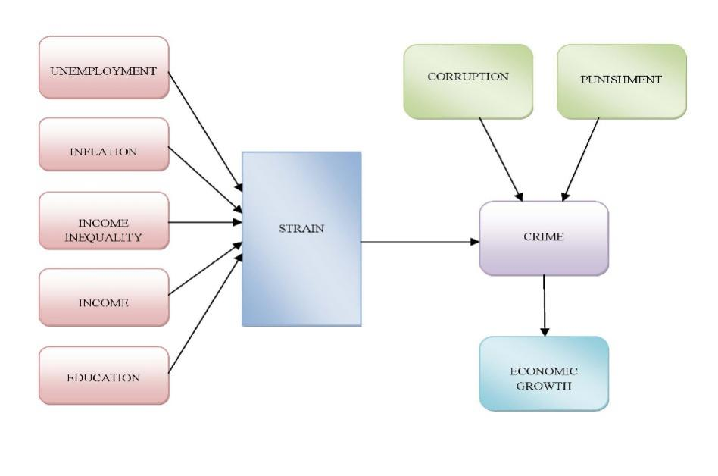
FIGURE 1. Interrelation between socio and macroeconomic variables and crime (Font 9)

TABLE 1. Pearson Correlation matrix among variables (Font 9)
 |  | Encouragement | Competency | Governance
 | Readiness | 0.0123 | 0.550 | 0.610
 | Competency |  | 1.000 | 0.058
 | Governance |  |  | 1.000

*Source: N/A

RESULTS AND DISCUSSION (Capital, 12pt Times New Roman)
Leave one blank

The important aspects in the interpretation of the results are identifying patterns of features, linking to previous results, linking to theory and explaining the results.
Leave two blanks

ACKNOWLEDGEMENT (Capital, 12pt Times New Roman)
Leave one blank

We would like to thank Universiti Kebangsaan Malaysia for the grant EP-2021-002.
Leave two blanks

REFERENCES (Capital, 12pt Times New Roman)

REFERENCE CITATIONS
- Every reference cited in the text must also appear in the reference list. All entries in the reference list must be citied in text. Cite references in text using the author-date method [e.g., Adams (1999)].
- If a work has two authors, always cite both names every time the work is referred to in the text.
- For works with three or more authors, use only the name of the first author followed by “et al.” and the year whenever the work is cited (in the reference list, however all names must be given).
- Pages number should be provided when specific arguments or findings of authors are paraphrased, summarized, or directly quoted. Examples :
First citation in text
Adams and Yong (2011) argued that . . .
Lim et al. (2003) found . . .

Subsequent citations
Ali and Mariah (2011) argued that . . . Lim et al. (2003) found . . .
- For parenthetical citations of two or more works, use alphabetical ordering and ampersands (&). Separate each cited work by semicolons except for multiple works by the same authors which must be separated by comas. Example:
Several researchers (e.g., Bushee 2001; Darrough & Rangan 2004, 2010; Norman & Kamran 2005; Shen & Chih 2005; Woidtke 2002) supported this argument.

REFERENCE LIST
- A Roman alphabetically-ordered reference list should be included at the end of the manuscript. All references cited in text must appear in the reference list. Authors are responsible for the accuracy and completeness of all information in a reference.
- Several references by the same author(s) should be ordered chronologically (earliest date first). Multiple references to works by an identical author(s) with the same publication date should be arranged alphabetically by the title that follows the date (excluding A or The) and differentiated by adding lowercase letters (a, b, c, etc.) immediately after the year. For periodicals, include an issue number only if the pages of the periodical are not numbered consecutively throughout the volume (i.e., if each issue begins with page 1)
- Type each entry using a hanging-indent format

REFERENCE (Center, 12pt, Times New Roman)

Journal article
Hassan, M.K., Rabbani, M.R., & Abdullah, Y. 2020. Socioeconomic impact of Covid-19 in MENA region and the role of Islamic finance. International Journal of Islamic Economics and Finance 4(1): 51-78.
Zulkefly, A.K., Aminudin M. & Mohd Azlan S.Z. 2004. Hubungan antara kadar pulangan nominal dengan permintaan deposit sistem perbankan Islam di Malaysia. Jurnal Ekonomi Malaysia 38: 3-27.

Book
Zafir M.M. & Fazilah M.H. 2017. Keusahawanan dan Mengurus Prestasi Sumber Manusia. Bangi: Penerbit UKM.

Chapter in book
Black, F., Jensen, M.C. & Scholes, M. 2002. The capital asset pricing model: some empirical test. In Studies in the Theory of Capital Markets edited by M.C. Jensen & R.A. Rozeff. New York: Praeger.

Internet Source
Anon. 2008. Occupational structures for wood based industry. http://www.dsd.gov.my/OA/Wood_Based_JD129990.pdf (accessed 26 June 2011).

Proceedings, presented papers, and dissertations

Locke, E.A., Durham, C.C. & Poon, J.M.L. 1995. Knowledge seeking as a group strategy to attain goals. In New developments in group dynamics and group effectiveness, E. A. Locke (Chair). Symposium conducted at the annual meeting of the Society of Industrial and Organizational Psychology, 18-20 May, Orlando, USA.
Ibrahim, M.H. & Said, R. 2011. Disaggregated consumer prices and oil prices pass-through: evidence from Malaysia. Proceedings of the VI Malaysian National Economics Conference: Vol. 1, edited by Mansor Jusoh, Nor Aini Idris, Tamat Sarmidi, Mohd. Adib Ismail & Ahmad Mohd Yusof, 5-7 June. Malacca, Malaysia, 296-305.
Che Embi, N.A. 2010. An examination of the initial performance of Malaysian shariah-compliant IPOs. Unpublished PhD. Diss., Universiti Kebangsaan Malaysia, Selangor, Malaysia.
Poon, J.M.L., Stevens, C.K. & Gannon, M.J. 1996. Effects of learning style and training method on reactions to cross-cultural training. Paper presented at the annual meeting of the Academy of Management, 12-15 August, Cincinnati, USA.

Working Paper
Ferrando, A. & Ruggieri, A. 2015 . Financial Constraints and Productivity: Evidence from Euro Area Companies. National Bureau of Economic Research Working Paper Series No. 1823.
Carrieri, F., Chaieb, I. & Errunza, V.R. 2010. Do implicit barriers matter for globalization? SSRN Working Paper available at http://ssrn.com/abstract=1730206.

Author 1
Address:
E-mail:

Author 2*
Address:
Email:

*Corresponding author

APPENDIX A (on a different page, if there is any)

APPENDIX B (on a different page, if there is any)

- Any poster presentation? Yes/No

