TITLE (TNR, 16, BOLD, CENTER, SINGLE SPACING, UPPERCASE)

Adam Hafiz^{1*}, Hannah², Aidil Amzar³ (TNR, 12, Align Left, Capitalized Each Word, Full Name)
¹ | Department of Account, Universiti Malaysia Kelantan, Malaysia  Email: adamhafiz@umk.edu.my
² | Department of Account, Universiti Malaysia Kelantan, Malaysia  Email: hannah@umk.edu.my
³ | Department of Account, Universiti Utara Malaysia, Malaysia  Email: aidilamzar@uum.edu.my
* | Corresponding Author
Article Info: |  |  | Abstract:
Article history:  Received date:14.11.2018  Revised date: 18.12.2018  Accepted date: 19.07.2019  Published date: 12.09.2019  To cite this document:  Kaviza, M. (2019). Kesan Teknik Peer Instruction dengan Penggunaan Sumber-sumber Sejarah Terhadap Pencapaian Mata Pelajaran Sejarah. International Journal of Education, Psychology and Counseling, 4 (32), 12-19.  DOI: 10.35631/IJEPC.432002.  This work is licensed under CC BY 4.0 |  |  | (TNR, 10, justify, single spacing) The abstract should not more than 300 words each. The abstract should not only indicate the subject and scope of the paper, but also summarize the author’s conclusion. Structured abstract must be a brief, comprehensive summary of the contents of the article. It allows readers to survey the contents of an article quickly. An Abstract summarizes the major aspects of a paper. It should succinctly summarize the purpose of the paper, the methods used, the major results, and conclusions.
 |  |  | Keywords:
 |  |  | (TNR, 10,, align left, single spacing), Min. 3 keywords Max. 7 keywords

Introduction – Heading 1 (TNR, 12, Bold, Align Left, Capitalize Each Word)
Tourism is one of the fastest growing development sectors in addition to other development strategic agendas such as energy, food, infrastructure ………….
(TNR, 12, single spacing, justify)

Literature Review – Heading 1 (TNR, 12, Bold, Align Left, Capitalize Each Word)
There are five points will be discussed in LR……
(TNR, 12, single spacing, justify)

Definition of Rural Tourism – Heading 2 (TNR, 12, Bold, Italic, Capitalize Each Word)
Sustainable tourism as defined by The World Tourism Organization (UNWTO) is tourism that takes full account of current and future economic, social and environmental impacts…
(TNR, 12, single spacing, justify)

Rural Tourism – Heading 3 (TNR, 12, Bold, Italic, Tab Inside, Capitalize Each Word)
The goal of sustainable tourism is to reduce poverty, respect socio-cultural authenticity……
(TNR, 12, single spacing, justify).

Table 1: Example (TNR, 12, Single Spacing, Bold, Centre, Capitalize Each Word)
Example | Example | Example
Example | Example | Example
Example | Example | Example
Source: (TNR,10, Single Spacing, Align Left, Capitalize Each Word)

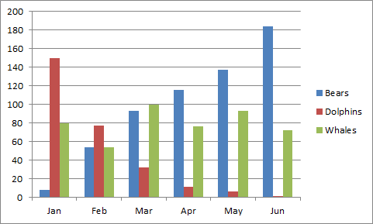
Figure 1: Example (TNR, 12, Single Spacing, Bold, Centre, Capitalize Each Word)
Source: (TNR,10, Single Spacing, Align Left, Capitalize Each Word)

Acknowledgements - Heading 1 (TNR, 12, Bold, Align Left, Capitalize Each Word)
Acknowledgments are compulsory for every paper. For example: The authors would like to acknowledge and extended special gratitude to the Global Academic Excellence (M) Sdn Bhd, who granted the Publication Grant Scheme for this project.

References (APA Sixth Edition, Single Spacing)
Chin, J. L. (2011). Women and Leadership: Transforming Visions and Current Contexts. Forum on Public Policy: A Journal of the Oxford Round Table, (2), 1–12.

(Minimum references 15 (70% from published work)
Notes:
* Please remove any numbering on heading and subheading.
* Example for numbering figure are: Figure 1, Figure 2, Figure 3 ….so on.
* Example for numbering table are: Table 1, Table 2, Table 3 …….so on.
* Please refer above example for table and figure.
* Please remove the page number
* Margin Normal: Top (2.54cm), Bottom (2.54cm), Left (2.54cm), Right (2.54cm)
* Minimum Pages 6 & Maximum Pages 20
* Minimum reference 15 (70% from published work)
* Affiliation and email for the authors are compulsory.
* It is preferred to use email from the institution.
* Please address which one is corresponding author by put the star as an example
* Acknowledgement is compulsory

