ENFORCEMENTS AND OFFENCES UNDER THE STRATA MANAGAMENT ACT

Ainul Ashiqin Ahmad Shuhaimi¹, Mariana Mohamed Osman², Noor Suzilawati Rabe³, Sh.Mazlina Syed Khuzzan Alhabshi⁴ , Damira Aripin⁵

^{1,2,3,4,5}Kulliyyah of Architecture and Environmental Design, Universiti Islam Antarabangsa Malaysia

Abstract

The rise in the number of strata residential buildings calls for the need for enforcement of governance relating to the wellbeing of strata residents as well as its management. The establishment of Management Body at the stage of Joint Management Body as well as the Management Corporation are both results of the enforcement of the Strata Management Act, that requires their registration with the Commissioner of Buildings (COB) to be given the rights to collect, manage and maintain the assigned residential strata properties. The aim of this study is to identify the most common issues occur under the legislation of strata management that results in the interference and enforcement by the COB, as replicated through to the number of enforcements taken by the COB. The result of the study shows that despite the enforcement of the Strata Management Act over the years, there are still a significant number of enforcement actions by the COB against the reported offences made with regards to the rights of both the residents as well as the management bodies. The constant rate of actions taken proves that there are still rooms for improvements within the Strata Act 757 itself to reduce issues, towards a more enforceable roles, standards and rules for future reference and service quality.

Keyword: High-rise Residential, Strata Residential, Commissioner of Building, Strata Management Body

INTRODUCTION
The increasing trend of high-rise strata living in urban Malaysian cities have further encouraged the growth of strata developments. Two Acts plays significant roles in ensuring the well-being of the purchasers, strata home owners as well as administering the developers and the management bodies, which is the Strata Title Act 1985 (Act 318) and the Strata Management Act 2013 (Act 757). Under the Act 757, with each completion of a stratified development, requires a management body to manage and maintain the building, facilities and the overall quality and sustainability of the common properties within the strata property, as well as the responsibilities of parties involved within the strata development.
Several studies have argued and concluded that the reality of the strata law that has given broad powers to the Management Bodies, but has failed to instil good governance. The law introduced does not counsel enforceable standards of good governance (Wong, 2019). Gaps were also found between the responsibilities of the management bodies and the residents’ role in ensuring smooth management and maintenance works.

LITERATURE REVIEW
Commissioner of Building (COB)
The COB in respect of a local authority area is necessary to be appointed for the purpose of administering and carrying out the provisions of the Act 757. According to the Act 757, the COB under this act may perform the duties and powers as conferred upon. The COB’s responsibilities include overlooking the registration of each Joint Management Body (JMB) and the Management Committee (MC) in fulfilling their responsibilities towards the residents and the residential strata properties. The Strata Management (Compounding of Offences) Regulations 2019 allows the Commissioner of Buildings (COB) to compound offences committed by strata owners as well as developers.

Management Bodies
The management bodies that may be in the form of a Joint Management body (JMB) or the Management Corporation (MC) varies according to different stage of strata management operation. The JMB, which consists of purchaser and tenants occupying the strata building and the strata developers is intended to ensure self-management prior to the formation of MC (Khalid et al., 2017). The MC that comes into existence upon the expiry of the preliminary management period, post JMB period. Both the JMB and MC plays significant roles and duties in managing and maintaining strata buildings, delegated responsibilities under the provision of Act 757. Based on the published COB Annual Reports, the following Table and Figure shows the distribution of strata schemes according to their star ratings:

Table 1: Total and Distribution of Strata Schemes’ Star Rating
 | 2016 | 2017 | 2018 | 2019
5 Star | 1% | 1% | 1% | 1%
4 Star | 3% | 9% | 10% | 10%
3 Star | 9% | 18% | 20% | 18%
2 Star | 7% | 22% | 31% | 25%
1 Star | 19% | 50% | 37% | 47%
No record | 61% | 0% | 0% | 0%
Total Schemes | 19,886 | 8,275 | 4,364 | 5,739

Figure 1: Strata Schemes Star Ratings
Source: COB Annual Report (2016-2019)

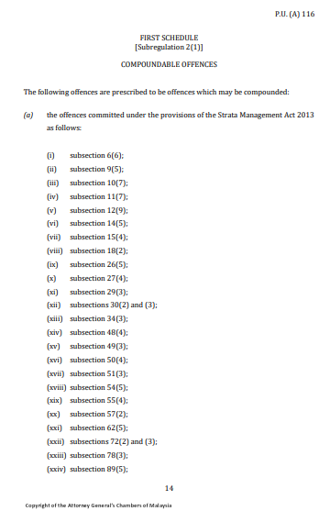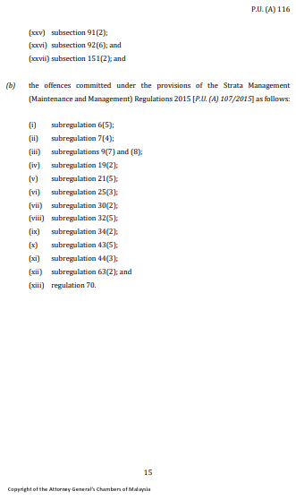
Figure 2: Strata Management (Compounding of Offences) Regulations 2019,
First Schedule

RESEARCH METHODOLOGY
This study conducts qualitative research, a document analysis, driven by the objective formulated, an analysis over data recorded by the COB and the National Housing Department (Jabatan Perumahan Negara, JPN) between the year 2017 to 2020. This analysis aims to show whether the gazettement of the Act 757 has the ability to improve the state of strata governance from the year it was gazetted and enforced in 2013. This data analysis discusses on the quality management with evidence provided within the available data set. The analysis is expected to show the most common and significant issues encountered through the enforcements taken by the COB according to the filed complaints and offences. The same data set will also be able to show the progressive state of management bodies throughout the years. The introduction of the Act 757 is expected to improve the overall quality, complementing its potential towards good governance.

ANALYSIS AND DISCUSSION
Table 2 shows the detailed offences under related sections, enforcement taken within the year 2020. From this table, it shows that the four highest number of enforcements taken, are related to the collected sums and matters of the account. Hence, the conclusion for the year 2020, matters in relation to the collection of fees and its accounts has the highest rate of non-compliance which leads to enforcements taken.

Table 2: Number of enforcements taken in the year 2020.
Section. No. | Quantity | Default by | Offence against (Section heading)
Sect. 13(3) | 9 | Any person | Prohibition on collection of moneys before accounts are opened
Sect. 123 | 284 | Any person | Criminal penalty for failure to comply with (Tribunal) award
Sect. 6(6) | 40 | Developer | Schedule of parcels to be filed with the Commissioner before sale of any parcel
Sect. 9(5) | 3 | Developer | Duties and powers of developer during developer's management period
Sect. 10(7) | 8 | Any person / Developer | Developer to establish maintenance account
Sect. 11(7) | 8 | Any person / Developer | Developer to establish sinking fund account
Sect. 12(9) | 1 | Developer | Purchaser and developer to pay Charges and contribution to sinking fund
Sect. 14(5) | 3 | Developer | Duties of developer in relation to accounts
Sect. 15(4) | 22 | Developer | Handing over by developer to the joint management body
Sect. 18(2) | 28 | Developer | Duty of developer to convene first annual general meeting of joint management body
Sect. 25(5)(6) | 500 | Purchaser | Parcel Owners to pay charges and contribution to the sinking fund, to the joint MB
Sect. 26(5) | 86 | MB | Offence against "Duties of joint management body in relation to accounts"
Sect. 27(4) | 5 | JMB | Dissolution of joint management body

CONCLUSION
This study has been able to explore the roles of the strata management stakeholders, namely the Commissioner of Buildings (COB) and the management bodies under the Act 757. The quality of the current landscape of the strata management, was drawn to conclusion through the analysed data. The astounding number of offences made and failure to comply, as well as the enforcement actions taken by the COB was able to highlight and identify the most common issues occurs in Strata Management.
Thus far, the Author is able to conclude that despite the acceptance and employment of the Act 757 and its regulations, the adoption of the Act can further be amended towards a more enforceable standards, rules and rights in strata management for the improvement of the overall quality of strata management.
The analysis concludes that majority of the offences made by parties involved are provisions related to the contribution to the maintenance and management fees, strata roll as well as roles and responsibilities of the management bodies. Both the management and the strata owners have the right to report and make claims against the other party that fails to comply with the Act and its regulations. The COB, having the governance power to ensure the effectiveness of the Act including the power to enforce.

REFERENCES
Berglund, E., Westerling, R., & Lytsy, P. (2017). Housing Type and Neighbourhood Safety Behaviour Predicts Self-rated Health, Psychological Well-being and Frequency of Recent Unhealthy Days: A Comparative Cross-sectional Study of the General Population in Sweden. Planning Practice & Research, 32(4), 444–465. https://doi.org/10.1080/02697459.2017.1374706
Darul Nafis Abas, Rozana Zakaria, Eeydzah Aminudin, Nurul Asmiera Ab Lah, Nur Syafiqah Aini Mohamad Nor Sharin, & Shaza Rina Sahamir. (2021). Issues and challenges of joint management body in high-rise residential facilities management: The developers. Civil Engineering and Architecture, 9(5), 33–40. https://doi.org/10.13189/cea.2021.091304
Evans, G. W., Kantrowitz, E., & Eshelman, P. (2002). Housing Quality and Psychological Well-Being Among the Elderly Population. The Journals of Gerontology Series B: Psychological Sciences and Social Sciences, 57(4), P381–P383. https://doi.org/10.1093/geronb/57.4.P381
KPKT. (2019). Laporan Tahunan COB PBT 2019. https://www.kpkt.gov.my/kpkt/resources/user_1/GALERI/PDF_Penerbitan/Laporan_Tahunan_COB/LP_COB_PBT_STRATA2019.pdf
Peterson, K. E. (2010). Security Risk Management. In The Professional Protection Officer (pp. 315–330). Elsevier. https://doi.org/10.1016/B978-1-85617-746-7.00027-4
Wong, J. Z. (2019). Towards Enforceable Standards, Rules And Rights In Strata Management: An Analysis. IIUM Law Journal, 27(2), 397–446. https://doi.org/10.31436/iiumlj.v27i2.433

