TITLE (TNR, 14, CENTER, UPPERCASE)

First A. Author*¹, Second B. Author2 and Third C. Author3

¹Authors’ Department, Institute, City, COUNTRY.
(E-mail: firstauthorsname@abcd.wxyz)
²Author’s Department, Institute, City, COUNTRY.
(Email: secondauthorsname@abcd.wxyz)
³Author’s Department, Institute, City, COUNTRY.
(E-mail: thirdauthorsname@abcd.wxyz)

Abstract (TNR, 12, single spacing, justify, Italic)

The abstract should not more than 300 words each. The abstract should not only indicate the subject and scope of the paper, but also summarize the author’s conclusion. Structured abstract must be a brief, comprehensive summary of the contents of the article. It allows readers to survey the contents of an article quickly. An Abstract summarizes the major aspects of a paper. It should succinctly summarize the purpose of the paper, the methods used, the major results, and conclusions.

Keywords
Keyword 1, Keyword 2, Keyword 3 (Min 3 key words & Max 5 Key words) (TNR, 12, Capitalize each word, Italic)

Introduction

This format is to be used for submissions that are published in the proceeding of the ICEEH 2018. We wish to give this proceeding a consistent, high-quality appearance. We therefore ask that authors follow some simple guidelines. In essence, you should format your paper exactly like this document. The easiest way to do this is simply to download a template from the conference web site and replace the content with your own material.

The extended abstract should be written in MS Word format in single-spaced in 12-point Times New Roman. Do not indent the text paragraphs. Please briefly explain these:

Purpose of the study
Design and methodology
Analysis and findings
Discussion
Conclusion
Originality/Value

Please observe Figure 1 and Table 1 to include figures and tables in the abstract, respectively.

Authors are requested to submit the Extended Abstracts (maximum of 3 pages in the length) in electronic form (MS-Word) via our Online Submission.

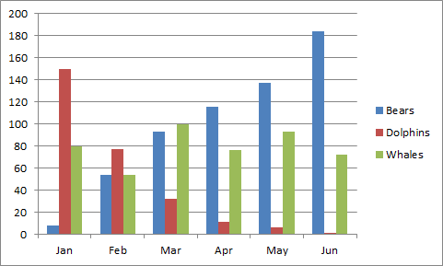

Figure 1. Example of figure for the extended abstract.

A table should be inserted like the one below and referred in the text.

Table 1. Example of table for the extended abstract
Contents of Table

Acknowledgement (TNR, 12, single spacing, justify, Italic)
The authors would like to express their appreciation for the support of the sponsors with Project No xxxx.

References (APA Sixth Edition)

