Full Paper Title in Title Case
(Each Word of the Title Should be Capitalised)

First Author (full first- and surname, no title)
Department or Division Name
Company or College Name (no postal address )
email address

Second Author
Department or Division Name
Company or College Name (no postal address )
email address

ABSTRACT
This file provides a template for writing papers for the conference. The conference proceedings will be published in an electronic format only and abstracts will also be printed to hand outs. The full paper in MS Word file shall be written in compliance with these instructions. Later on it will be converted into Portable Document Format (PDF). An abstract not exceeding 300 words should appear on the top of the first page, after the title of the paper in chapter titled "Abstract" (without chapter number), after the names of the authors and the contact information of the corresponding author. It should include research background, problem statement, objectives, methods used, research results and impacts of your study

Keywords: Up to five keywords, 10 point type, left-justified

INTRODUCTION
It is expected that authors will submit carefully written and proofread material. Spelling and grammatical errors, as well as language usage problems, are not acceptable. There is no strict limitation to the number of pages, but it is suggested that the paper length should not exceed 15 pages.
Papers should clearly describe the background of the subject, the authors work, including the methods used, and concluding discussion on the importance of the work. Papers are to be prepared in English, Bahasa Melayu or Arabic. Acronyms should be written out at their first appearance.

paper format
The uniform outlook will help the reader to follow the proceedings. This can be obtained most easily if authors use this template file to construct their papers. Please note the following details: this template is an A4 format with 20 mm margins left, right, top and bottom. Header and footer shall be positioned 16 mm from the edge.
All text paragraphs should be single spaced, with first line intended by 10 mm. Double spacing should only be used before and after headings and subheadings as shown in this example. Position and style of headings and subheadings should follow this example. No spaces should be placed between paragraphs. Please DO NOT change any of the above mentioned page, paragraph and font settings.

Header, Footer, Page Numbering
If this template is used when writing the full paper, headers and footers will be set automatically. Authors are only asked to replace the "XXX" number (with the real number assigned once the abstract was accepted) on the header of the first page and on the footer of other pages in order to set a unique page number in the Proceedings.

Fonts
Papers should use 12-point Times New Roman font. The styles available are bold, italic and underlined.
It is recommended that text in figures is not smaller than 10-point font size.

Tables and Figures
Figure captions and table headings should be sufficient to explain the figure or table without needing to refer to the text. Figures and tables not cited in the text should not be presented. Styles Heading Table and Caption Figure are available in this template for tables and figures.
The following is the example for Table 1.
Table 1 Title of Example Table
Header | X | Improved
(Flow control valves) Air operated valves | 4 | Yes
Check valves | 2 | Yes
Line discharge check valves | 4 | Yes
Pump discharge check valves | 3 | Yes
Motor driven pumps | 2 | Yes
Motor driven pumps | 2 | No

Tables and figures should be placed close after their first reference in the text. All figures and tables should be numbered with Arabic numerals. Table headings should be centred above the tables. Figure captions should be centred below the figures.

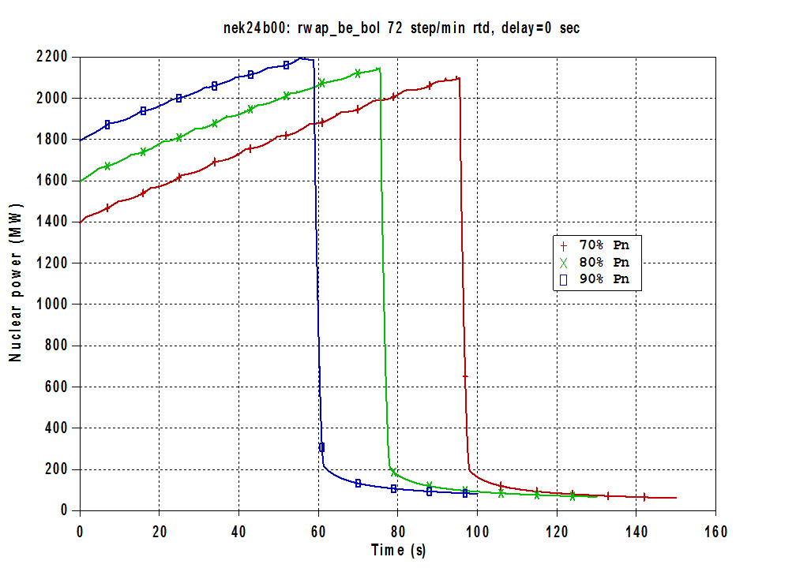
Figure 1: Hundertwasser’s Painting Sunset without Value (1970)

(0)

SUBMITTING THE Paper
Paper number (in the format "XXX") is assigned to each abstract after it was accepted and authors are kindly asked to place the paper number to the correct positions in the header and footer before submitting the final version of the abstract. Final dateline for full paper submission is on 30th APRIL 2018.
The final paper file name should be the same name as for the accepted abstract (e.g. “SWAN2018-XXX.doc”).

Conference Programme and proceedings
The abstracts and final papers are compiled into the conference Proceedings CD-ROM.

conclusion
Conclusions should state concisely the most important propositions of the paper as well as the author’s views of the practical implications of the results.

- ACKNOWLEDGEMENTS

It is encouraged to write the acknowledgement to research grant and Malaysia Government where appropriate.

REFERENCES
Battikha, Mireille G. and Colin H. Davidson (1996) “Cause and Effect 3-D Model for measuring performance in Construction Acceleration: a Decision Support System” Building Research and Information, Vol. 24, No 6, pp.351-357.

Davidson, Colin H. (ed) (1998) Information in the Building Industry – Problems and Solutions, Montréal, IF Research Corporation, (electronic book on the Internet).

Phillips, E. Barbara (1996) City Lights: Urban and Suburban Life in the Global Society. Oxford University Press; New York.

Scottish Intercollegiate Guidelines. 2001. Hypertension in the elderly. (SIGN publication 20) [internet] Edinburgh: SIGN (Published 2001) Available at:
http://www.sign.ac.uk/pdf/sign49.pdf [Accessed 17 March 2005].

