ZAWED 2019 Template

Title Times, Bold-face, 14-point and Center
¹First Author, ²Second Author and ³Third Author (Author Name (s): Forename Middle, Family name Roman, Capital and Center)
¹Department Affiliation, Institute or University Affiliation and Country
²Department Affiliation, Institute or University Affiliation and Country
³Department Affiliation, Institute or University Affiliation and Country

zzz@uum.edu.my;xxxx@yahoo.com; yyy@gmail.com
FORMATTING
Page Size
The entire manuscript, including abstract of 150-250 words and key words (not more than five key words). Tables, figures and references, should be within 5000 words and should be typed, 1.5 spaced, on A4 paper in 12 point Times New Roman font. Standard margins (2.5" on the top and bottom and 2.5" on the left and right), on one side of the paper only, with pages numbered consecutively.
ABSTRACT
HEADING in capital, bold face font and center 12- point
An Abstract (150-250 words and key words not more than five key words) summarizes the major aspects of a paper. It is usually one paragraph long, and should succinctly summarize the purpose of the paper, the methods used, the major results, and the author's impretations and conclusions. Avoid citing references in the abstract. Paraphrase rather than quoting. Use active rather than passive voice (but without personal pronouns). Abbreviations should be introduced at the first mention in the text.
Keywords: list up not more than five key words in alphabetical order, separated by commas.

HEADING OF MANUSCRIPT
Section Heads/Primary Heading centered, bold, 11-point and uppercase letters. For example:-
INTRODUCTION
METHODS
RESULTS
CONCLUSION
REFERENCES
Subsection Heads. Sub-section heads or secondary headings flush left, bold, 11-point in upper and lower case as shown. For subsection heads, a word like the or a is not capitalized unless it is the first word of the header. For example:-
Cloud Computing (level 1)

Tertiary Headings. Sub-sub headings should be indented, bold, 11-point, lower case paragraphs letters of each words. For example:-

Trust management in distributed systems (level 2)

Next sub headings — indented, bold, italicized, lowercase paragraphs letters of each words
Computing trust (level 4)
— indented, italicized, lowercase paragraphs letters of each words
Trust management system (level 5)
TEXT
The first paragraph text begins with no indent. The first paragraph text begins with no indent. The first paragraph text begins with no indent. The first paragraph text begins with no indent. The first paragraph text begins with no indent. The first paragraph text begins with no indent.

TEXT CITATION OF REFERENCES
Within text of an article, references are to be cited by last name of author(s) and year publication. For example:-
Lave and Wenger (1991) proposed...
... was discovered ( Lave & Wenger, 1991)
Sparrow (1980a) discovered...
It was also noted (Sparrow, 1980b; Kheisin, 1992) that...

LENGTH
Each manuscript should not exceed 25 pages.
TABLES
Numbers tables consecutively and use table numbers when refereeing to a table (Table 1, Tables 2, 3...).Use uppercase and lowercase letters for the title of the tables as shown here. Table caption must briefly explain the contents of the table. Round to two decimal digits of accuracy while reporting correlations, proportions, and inferential statistics such as t, F, and x² . For example:
Table 1
Errors by Category and their Frequency of Occurrences in Dyslexic Children's Reading and Spelling of Isolated Bahasa Melayu Words
Category of Errors | n | %
Substitutes vowel | 1286 | 20.34
Omitted consonants * | 786 | 12.43
Nasals (m, n) | 770 | 12.17
Substitutes consonants * | 577 | 9.13
Omits vowel | 511 | 8.03
Substitutes word | 384 | 6.07
Adds consonants | 363 | 5.74
Substitutes with non-words | 272 | 4.3
Reversals | 268 | 4.24
Incorrect sequence | 224 | 3.54
Omits syllable | 167 | 2.64
Liquids (1, r) | 156 | 2.47
Substitutes vowel with consonant /  consonant with vowel ** | 143 | 2.26
Substitutes nasals for liquid | 124 | 1.96
Adds vowel | 124 | 1.96
Syllable Division Confusion | 94 | 1.49
Adds syllable | 74 | 1.17
Note. * excludes m, n, 1 ,r
** if: substitution of a vowel with a consonant (excluding m, n, 1, r) or substitution of a consonant (including m, n, 1, r) with a vowel

FIGURES
Place and label figure captions below each figure, in uppercase and lowercase letters. Type (Figure 1. Captions...). See example as shown.

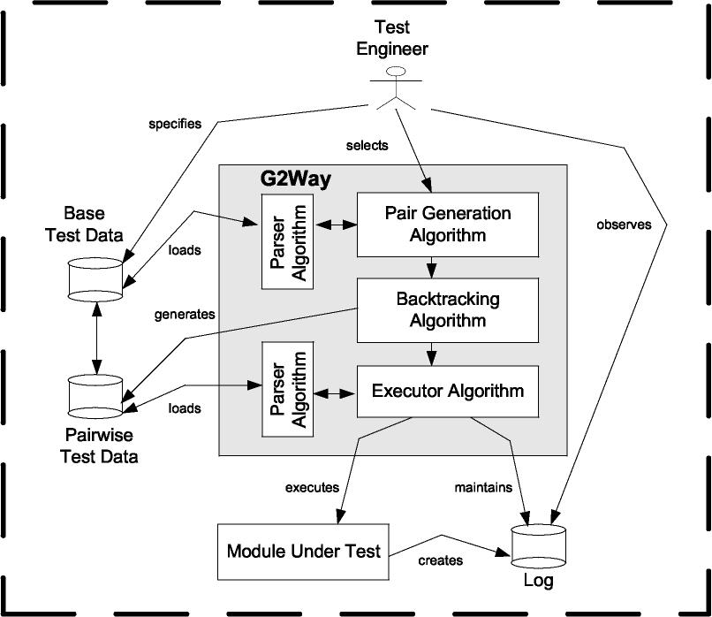
generates
Base
Test Data
Pairwise Test Data
loads
Module Under Test
executes
-4-111.-
Executor Algorithm
Backtracking Algorithm
Log
I
I
I
I
I
_I
selects
G2Way
Pair Generation Algorithm
-4-1111
loads
Test
Engineer
specifies
Figure 1. Overview of the G2Way Strategy

Acknowledgments

Any acknowledgments by the author may appear here. The Acknowledgments of people, grants, funds, etc should be brief and concise. The acknowledgments section is optional.

REFERENCES
List of References shall be arranged in alphabetical order of last name of first-named author for with more than one author. Do not number them. Please refer and follow the APA Style 6th ed. For examples:-

Journal article
Raymond, A. (2000). Perceptual comparisons through the mind's eye. Memory & Cognition, 23, 635-647.
Book
Slynn, J.R. (2007). What is intelligence?-beyond the Flynn effect. Cambridge: Cambridge University Press.
Chapter in a book or entry in a reference book
Tunes, T. (2002). The role of systems of signs in reasoning. In T. Brown & Smith (Eds.), Reductionism and the development of knowledge (pp. 133-158). Mawah, NJ: Erlbaum.
Journal article with DOI (Digital Object Identifier)
Herbst, K.L., & Kulik, J.A. (2005). Volunteer support, marital status, and the survival
times of terminally ill patients. Health Psychology, 24, 225-229. doi: 10.1037/02786133.24.2.225
Journal article without DOI
Valen, G., Knapp, S., & Doe, J. (2001). Role of reference elements in the section of resources by psychology undergraduates. Journal of Bibliographic Research, 5, 117-123. Retrieved from http://jbt.org/articles
Corporate author
American Psychological Association(2010). Publication manual of the American Psychological Association (6th ed). Washington, DC: Author.
Magazine article
Chamberlin, J. Novotney, A., Packard, E., & Price, M. (2008, May). Enhancing worker well-being: occupational health psychologists convene to share their research on work, stress, and health. Monitor on Psychology, 39(5), 26-29.
Newspaper article
Schwartz, J. (1993, September 30). Obesity affects economics, social status. The Washington Post, pp. Al, A4.
Unpublished doctoral dissertation or thesis
Author, A, A. (1978). Title of doctoral dissertation or master's thesis (Unpublished doctoral dissertation or master's thesis). Name of Institution, Location.
Proceeding published regularly online
Houzel, S., Collins, C.E., Wong, P., Kaas, J.H., Lent, R. (2008). The basic nonuniformity of the cerebral cortex. Proceedings of the National Academy of Sciences 105, 12593-12598. doi: 10.1073/pnas.0805417105

